VISVESVARAYA TECHNOLOGICAL UNIVERSITY

“JnanaSangama”, Belgaum -590014, Karnataka.



LAB REPORT

on

OPERATING SYSTEMS

Submitted by

Varshitha B (1WA23CS035)

in partial fulfillment for the award of the degree of

# BACHELOR OF ENGINEERING

in

COMPUTER SCIENCE AND ENGINEERING



B.M.S. COLLEGE OF ENGINEERING

(Autonomous Institution under VTU)

BENGALURU-560019

Feb-2025 to June-2025

B. M. S. College of Engineering,

Bull Temple Road, Bangalore 560019

(Affiliated To Visvesvaraya Technological University, Belgaum)

Department of Computer Science and Engineering



CERTIFICATE

This is to certify that the Lab work entitled “OPERATING SYSTEMS – 23CS4PCOPS” carried out by Varshitha B (1WA23CS035), who is Bonafide student of B. M. S. College of Engineering. It is in partial fulfilment for the award of Bachelor of Engineering in Computer Science and Engineering of the Visvesvaraya Technological University, Belgaum during the year Feb 2025- June 2025. The Lab report has been approved as it satisfies the academic requirements in respect of a OPERATING SYSTEMS - (23CS4PCOPS) work prescribed for the said degree.

Dr Seema Patil Dr. Kavitha Sooda

Assistant Professor Professor and Head

Department of CSE Department of CSE

BMSCE, Bengaluru BMSCE, Bengaluru

Index Sheet

|  |  |  |
| --- | --- | --- |
| Sl.  No. | Experiment Title | Page No. |
| 1. | Write a C program to simulate the following non-pre-emptive CPU scheduling algorithm to find turnaround time and waiting time.  →FCFS  → SJF (pre-emptive & Non-preemptive) | 1-7 |
| 2. | Write a C program to simulate the following CPU scheduling algorithm to find turnaround time and waiting time.  → Priority (pre-emptive & Non-pre-emptive)  →Round Robin (Experiment with different quantum sizes for RR algorithm) | 8-20 |
| 3. | Write a C program to simulate multi-level queue scheduling algorithm considering the following scenario. All the processes in the system are divided into two categories – system processes and user processes. System processes are to be given higher priority than user processes. Use FCFS scheduling for the processes in each queue. | 21-26 |
| 4. | Write a C program to simulate Real-Time CPU Scheduling algorithms:   1. Rate- Monotonic 2. Earliest-deadline First | 27-39 |
| 5. | Write a C program to simulate producer-consumer problem using semaphores | 40-44 |
| 6. | Write a C program to simulate the concept of Dining Philosophers problem. | 45-50 |
| 7. | Write a C program to simulate Bankers algorithm for the purpose of deadlock avoidance. | 51-55 |
| 8. | Write a C program to simulate deadlock detection | 56-60 |
| 9. | Write a C program to simulate the following contiguous memory allocation techniques  a) Worst-fit   1. Best-fit 2. First-fit | 61-68 |
| 10. | Write a C program to simulate page replacement algorithms   1. FIFO 2. LRU 3. Optimal | 69-80 |

Course Outcomes

|  |  |
| --- | --- |
| C01 | Apply the different concepts and functionalities of Operating System |
| C02 | Analyse various Operating system strategies and techniques |
| C03 | Demonstrate the different functionalities of Operating System. |
| C04 | Conduct practical experiments to implement the functionalities of Operating system. |

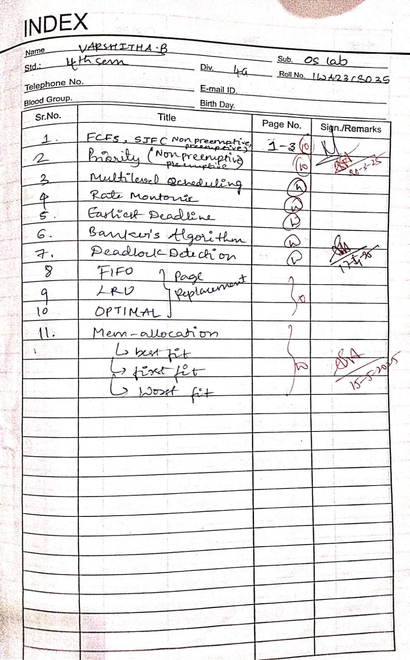

Program -1

Question:

Write a C program to simulate the following non-pre-emptive CPU scheduling algorithm to find turnaround time and waiting time.

→FCFS

→ SJF (pre-emptive & Non-preemptive)

Code:

#include <stdio.h>

#include <stdlib.h>

struct process {

int id, AT, BT, CT, TAT, WT, RT, remaining_BT;

int completed;

};

void sort_by_AT(struct process p[], int n) {

for (int i = 0; i < n - 1; i++) {

for (int j = i + 1; j < n; j++) {

if (p[i].AT > p[j].AT) {

struct process temp = p[i];

p[i] = p[j];

p[j] = temp;

}

}

}

}

void calculate_FCFS(struct process p[], int n) {

sort_by_AT(p, n);

int currentTime = 0;

for (int i = 0; i < n; i++) {

if (currentTime < p[i].AT)

currentTime = p[i].AT;

p[i].RT = currentTime - p[i].AT;

p[i].CT = currentTime + p[i].BT;

currentTime = p[i].CT;

p[i].TAT = p[i].CT - p[i].AT;

p[i].WT = p[i].TAT - p[i].BT;

}

}

void calculate_SJF_NonPreemptive(struct process p[], int n) {

int completed = 0, currentTime = 0;

while (completed < n) {

int shortest = -1, minBT = 10000;

for (int i = 0; i < n; i++) {

if (!p[i].completed && p[i].AT <= currentTime && p[i].BT < minBT) {

minBT = p[i].BT;

shortest = i;

}

}

if (shortest == -1) {

currentTime++;

} else {

p[shortest].RT = currentTime - p[shortest].AT;

p[shortest].CT = currentTime + p[shortest].BT;

currentTime = p[shortest].CT;

p[shortest].TAT = p[shortest].CT - p[shortest].AT;

p[shortest].WT = p[shortest].TAT - p[shortest].BT;

p[shortest].completed = 1;

completed++;

}

}

}

void calculate_SJF_Preemptive(struct process p[], int n) {

int completed = 0, currentTime = 0;

for (int i = 0; i < n; i++) {

p[i].remaining_BT = p[i].BT;

}

while (completed < n) {

int shortest = -1, minBT = 10000;

for (int i = 0; i < n; i++) {

if (!p[i].completed && p[i].AT <= currentTime && p[i].remaining_BT < minBT) {

minBT = p[i].remaining_BT;

shortest = i;

}

}

if (shortest == -1) {

currentTime++;

} else {

if (p[shortest].remaining_BT == p[shortest].BT)

p[shortest].RT = currentTime - p[shortest].AT;

p[shortest].remaining_BT--;

currentTime++;

if (p[shortest].remaining_BT == 0) {

p[shortest].CT = currentTime;

p[shortest].TAT = p[shortest].CT - p[shortest].AT;

p[shortest].WT = p[shortest].TAT - p[shortest].BT;

p[shortest].completed = 1;

completed++;

}

}

}

}

void display(struct process p[], int n) {

printf("\nProcess\tAT\tBT\tCT\tTAT\tWT\tRT\n");

for (int i = 0; i < n; i++) {

printf("%d\t%d\t%d\t%d\t%d\t%d\t%d\n", p[i].id, p[i].AT, p[i].BT, p[i].CT, p[i].TAT, p[i].WT, p[i].RT);

}

}

int main() {

int n, choice;

printf("Enter number of processes: ");

scanf("%d", &n);

struct process p[n];

for (int i = 0; i < n; i++) {

p[i].id = i + 1;

printf("Enter Arrival Time (AT) for process %d: ", i + 1);

scanf("%d", &p[i].AT);

printf("Enter Burst Time (BT) for process %d: ", i + 1);

scanf("%d", &p[i].BT);

p[i].completed = 0;

}

while (1) {

printf("\nMenu:\n");

printf("1. First Come First Serve (FCFS)\n");

printf("2. Shortest Job First (SJF) - Non Preemptive\n");

printf("3. Shortest Job First (SJF) - Preemptive\n");

printf("4. Exit\n");

printf("Enter choice: ");

scanf("%d", &choice);

switch (choice) {

case 1:

calculate_FCFS(p, n);

display(p, n);

break;

case 2:

calculate_SJF_NonPreemptive(p, n);

display(p, n);

break;

case 3:

calculate_SJF_Preemptive(p, n);

display(p, n);

break;

case 4:

exit(0);

default:

printf("Invalid choice. Try again.\n");

}

}

return 0;

}

Output:

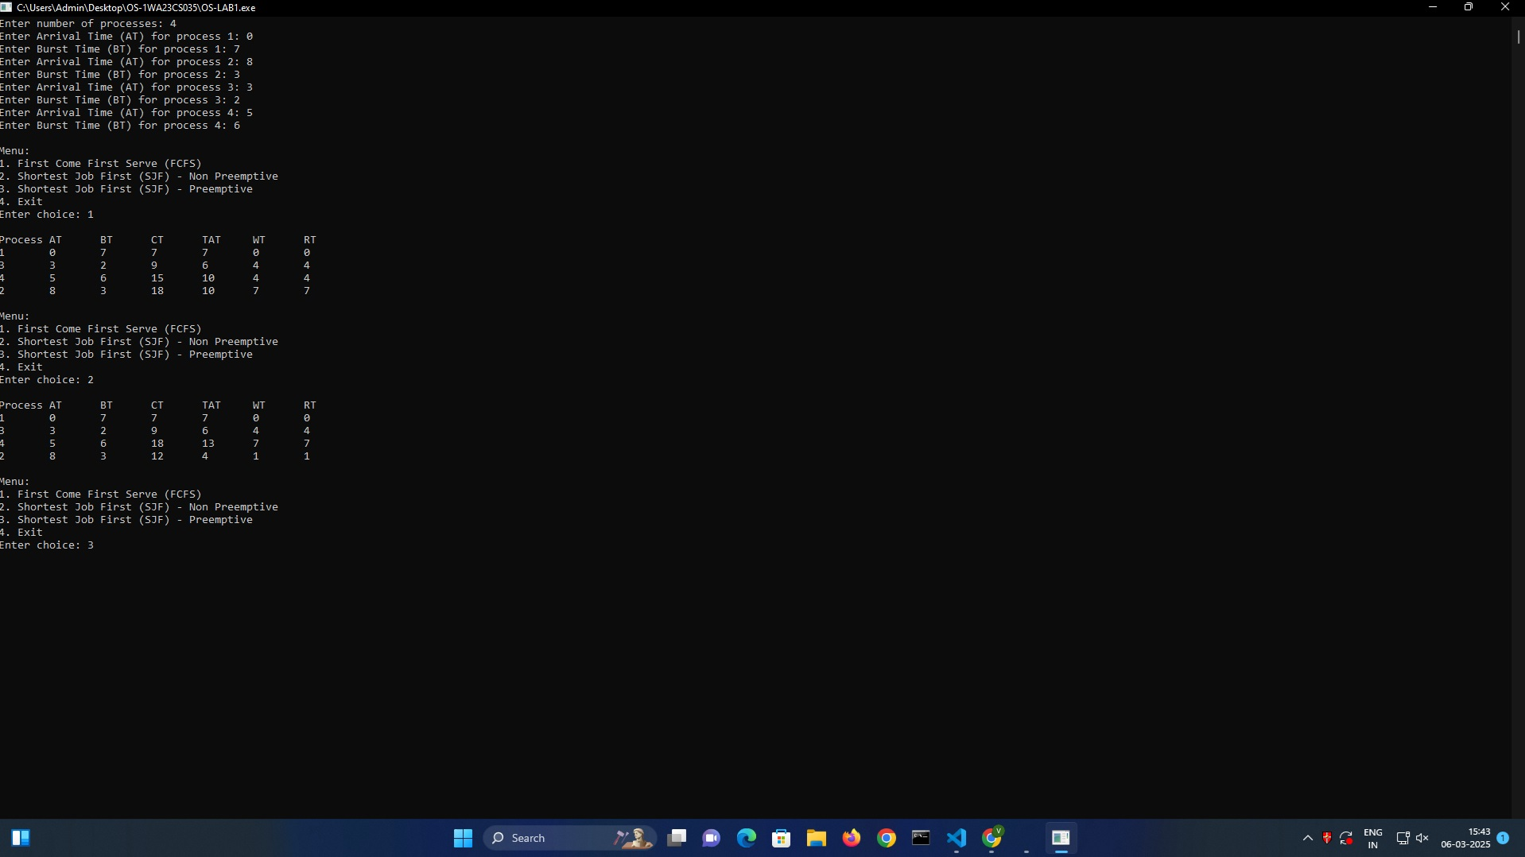

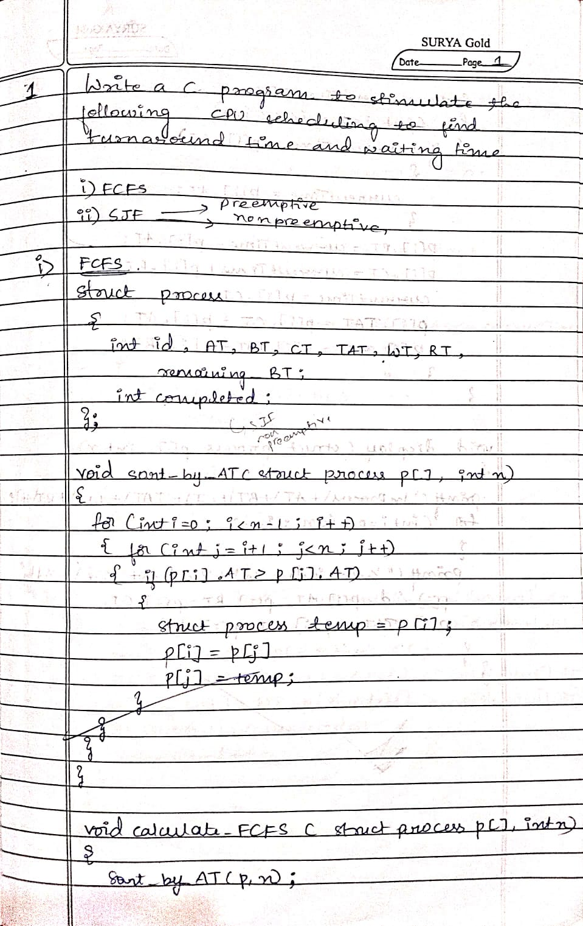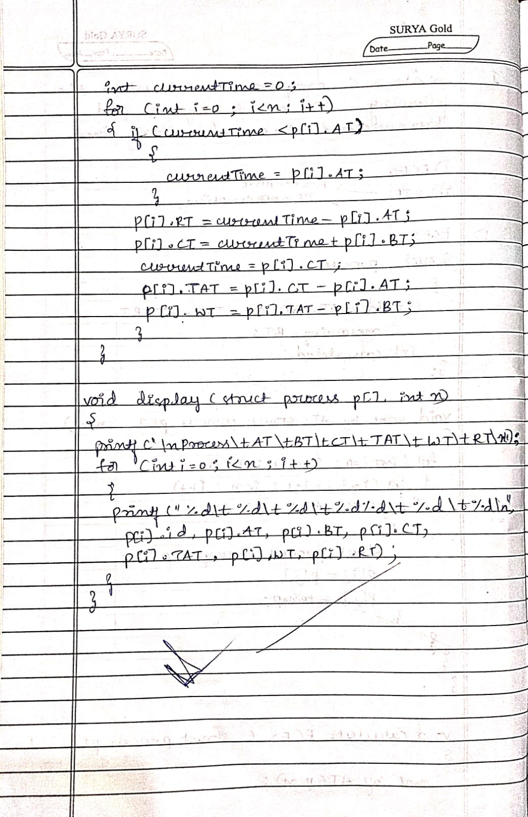

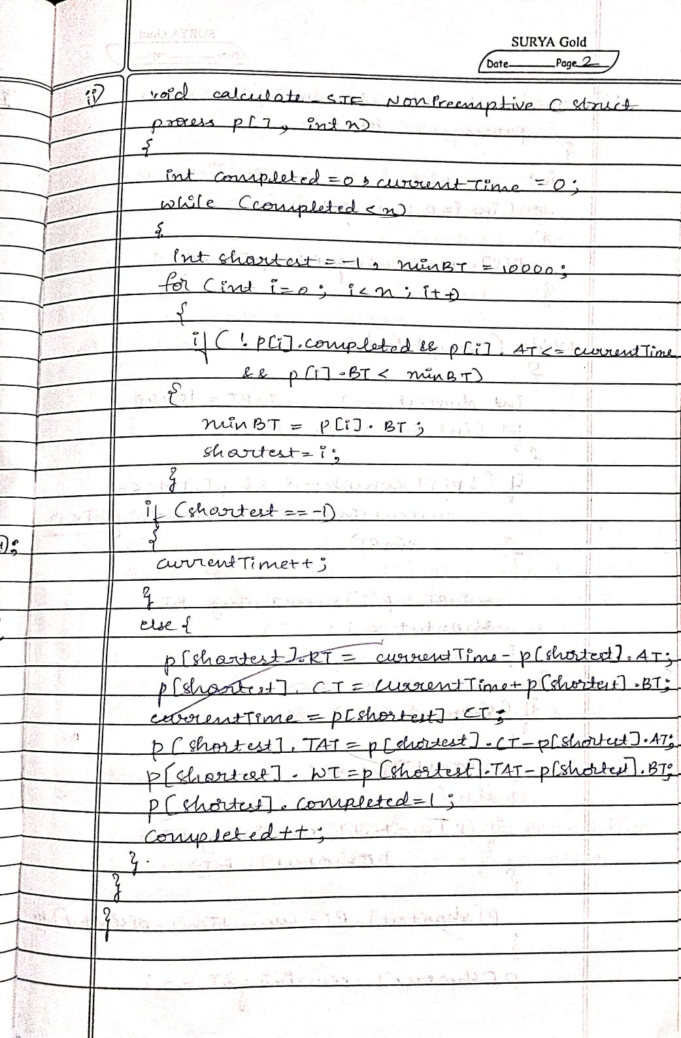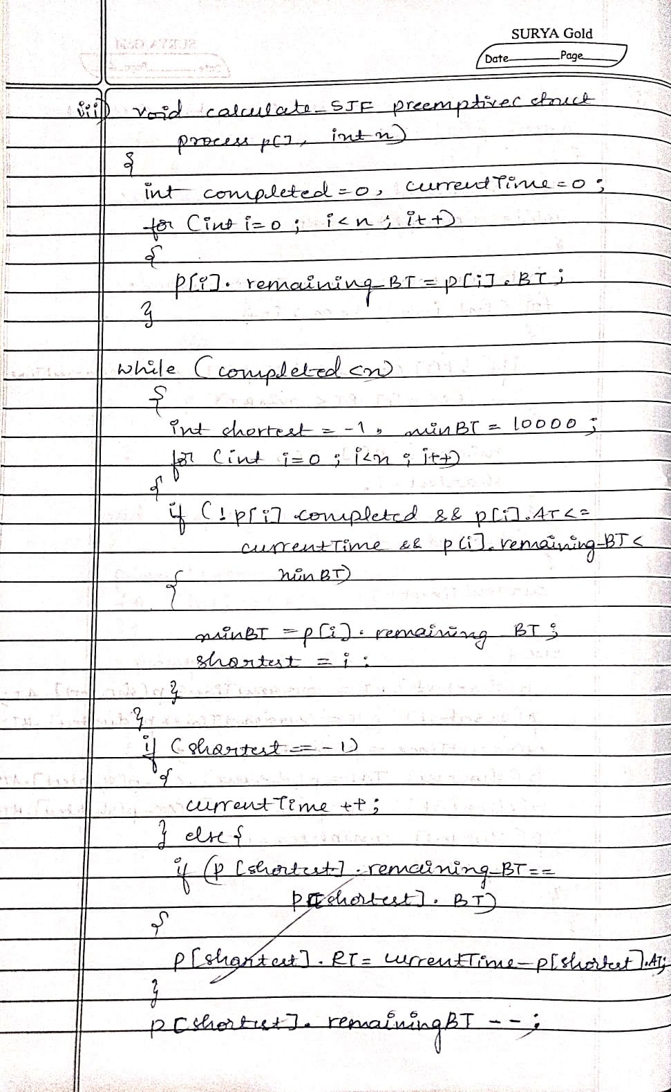

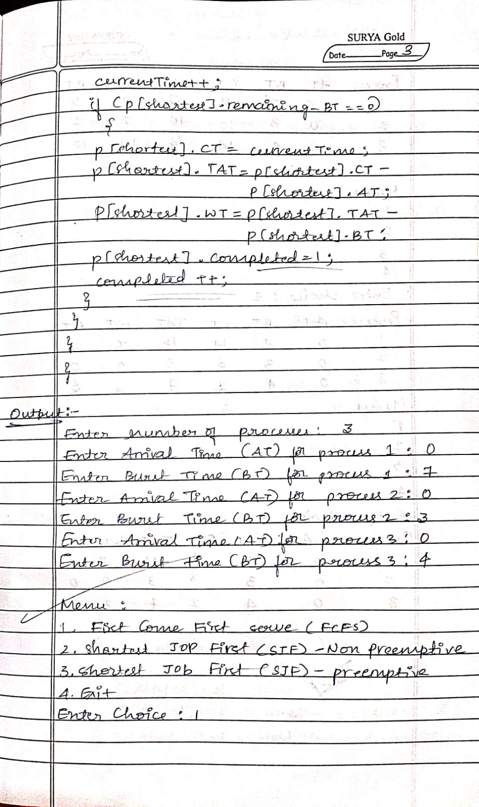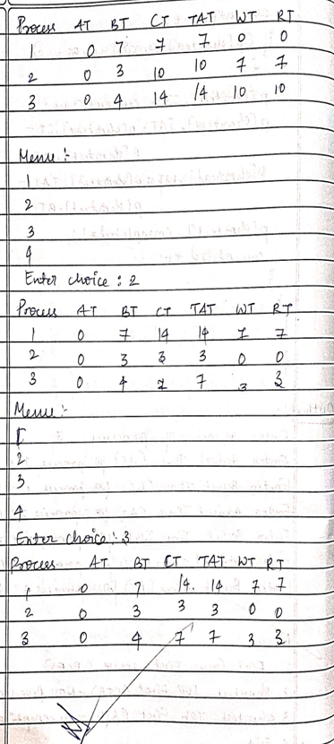

Program -2

Question:

Write a C program to simulate the following CPU scheduling algorithm to find turnaround time and waiting time.

→ Priority (pre-emptive & Non-pre-emptive)

→Round Robin (Experiment with different quantum sizes for RR algorithm)

Code:

//Priority scheduling

#include <stdio.h>

#define MAX 10

typedef struct {

int pid, at, bt, pt, remaining_bt, ct, tat, wt, rt, is_completed, st;

} Process;

// Function for Non-Preemptive Priority Scheduling

void nonPreemptivePriority(Process p[], int n) {

int time = 0, completed = 0;

while (completed < n) {

int highest_priority = -1, selected = -1;

for (int i = 0; i < n; i++) {

if (p[i].at <= time && !p[i].is_completed && p[i].pt > highest_priority) {

highest_priority = p[i].pt;

selected = i;

}

}

if (selected == -1) {

time++;

continue;

}

// If RT is not yet calculated, calculate it

if (p[selected].rt == -1) {

p[selected].st = time; // Start time

p[selected].rt = time - p[selected].at; // Response Time = Start Time - Arrival Time

}

time += p[selected].bt;

p[selected].ct = time;

p[selected].tat = p[selected].ct - p[selected].at;

p[selected].wt = p[selected].tat - p[selected].bt;

p[selected].is_completed = 1;

completed++;

}

}

// Function for Preemptive Priority Scheduling

void preemptivePriority(Process p[], int n) {

int time = 0, completed = 0;

while (completed < n) {

int highest_priority = -1, selected = -1;

for (int i = 0; i < n; i++) {

if (p[i].at <= time && p[i].remaining_bt > 0 && p[i].pt > highest_priority) {

highest_priority = p[i].pt;

selected = i;

}

}

if (selected == -1) {

time++;

continue;

}

// If RT is not yet calculated, calculate it

if (p[selected].rt == -1) {

p[selected].st = time; // Start time

p[selected].rt = time - p[selected].at; // Response Time = Start Time - Arrival Time

}

p[selected].remaining_bt--;

time++;

if (p[selected].remaining_bt == 0) {

p[selected].ct = time;

p[selected].tat = p[selected].ct - p[selected].at;

p[selected].wt = p[selected].tat - p[selected].bt;

completed++;

}

}

}

// Function to display the results of processes

void displayProcesses(Process p[], int n) {

float avg_tat = 0, avg_wt = 0, avg_rt = 0;

printf("\nPID\tAT\tBT\tPriority\tCT\tTAT\tWT\tRT\n");

for (int i = 0; i < n; i++) {

printf("%d\t%d\t%d\t%d\t\t%d\t%d\t%d\t%d\n",

p[i].pid, p[i].at, p[i].bt, p[i].pt, p[i].ct, p[i].tat, p[i].wt, p[i].rt);

avg_tat += p[i].tat;

avg_wt += p[i].wt;

avg_rt += p[i].rt;

}

printf("\nAverage TAT: %.2f", avg_tat / n);

printf("\nAverage WT: %.2f", avg_wt / n);

printf("\nAverage RT: %.2f\n", avg_rt / n);

}

int main() {

Process p[MAX];

int n, choice;

// Asking the user for the number of processes

printf("Enter the number of processes: ");

scanf("%d", &n);

// Getting arrival times, burst times, and priorities for each process

for (int i = 0; i < n; i++) {

p[i].pid = i + 1; // Process ID starts from 1

printf("\nEnter Arrival Time, Burst Time, and Priority for Process %d:\n", p[i].pid);

printf("Arrival Time: ");

scanf("%d", &p[i].at);

printf("Burst Time: ");

scanf("%d", &p[i].bt);

printf("Priority (higher number means higher priority): ");

scanf("%d", &p[i].pt);

p[i].remaining_bt = p[i].bt; // Initialize remaining burst time

p[i].is_completed = 0; // Mark process as incomplete

p[i].rt = -1; // Response time will be calculated later

}

// Menu to choose the scheduling method

while (1) {

printf("\nPriority Scheduling Menu:\n");

printf("1. Non-Preemptive Priority Scheduling\n");

printf("2. Preemptive Priority Scheduling\n");

printf("3. Exit\n");

printf("Enter your choice: ");

scanf("%d", &choice);

switch (choice) {

case 1:

nonPreemptivePriority(p, n);

printf("Non-Preemptive Scheduling Completed!\n");

displayProcesses(p, n);

break;

case 2:

preemptivePriority(p, n);

printf("Preemptive Scheduling Completed!\n");

displayProcesses(p, n);

break;

case 3:

printf("Exiting...\n");

return 0;

default:

printf("Invalid choice! Try again.\n");

}

}

return 0;

}

Output:

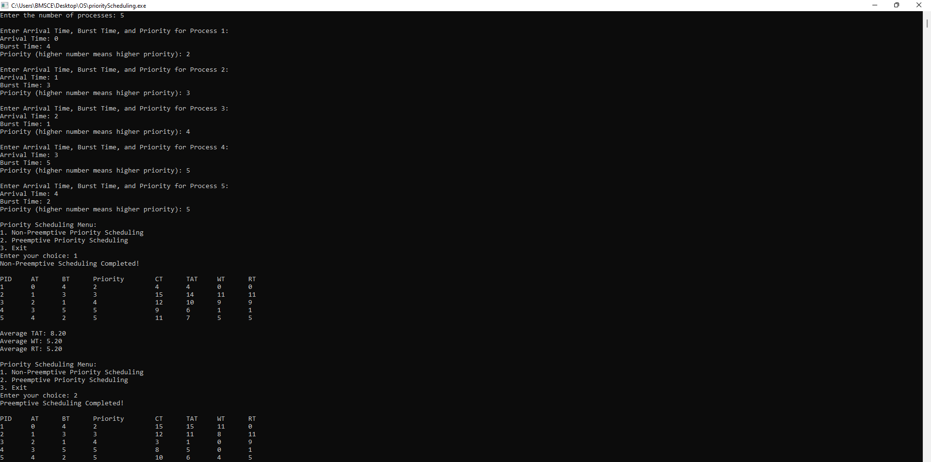

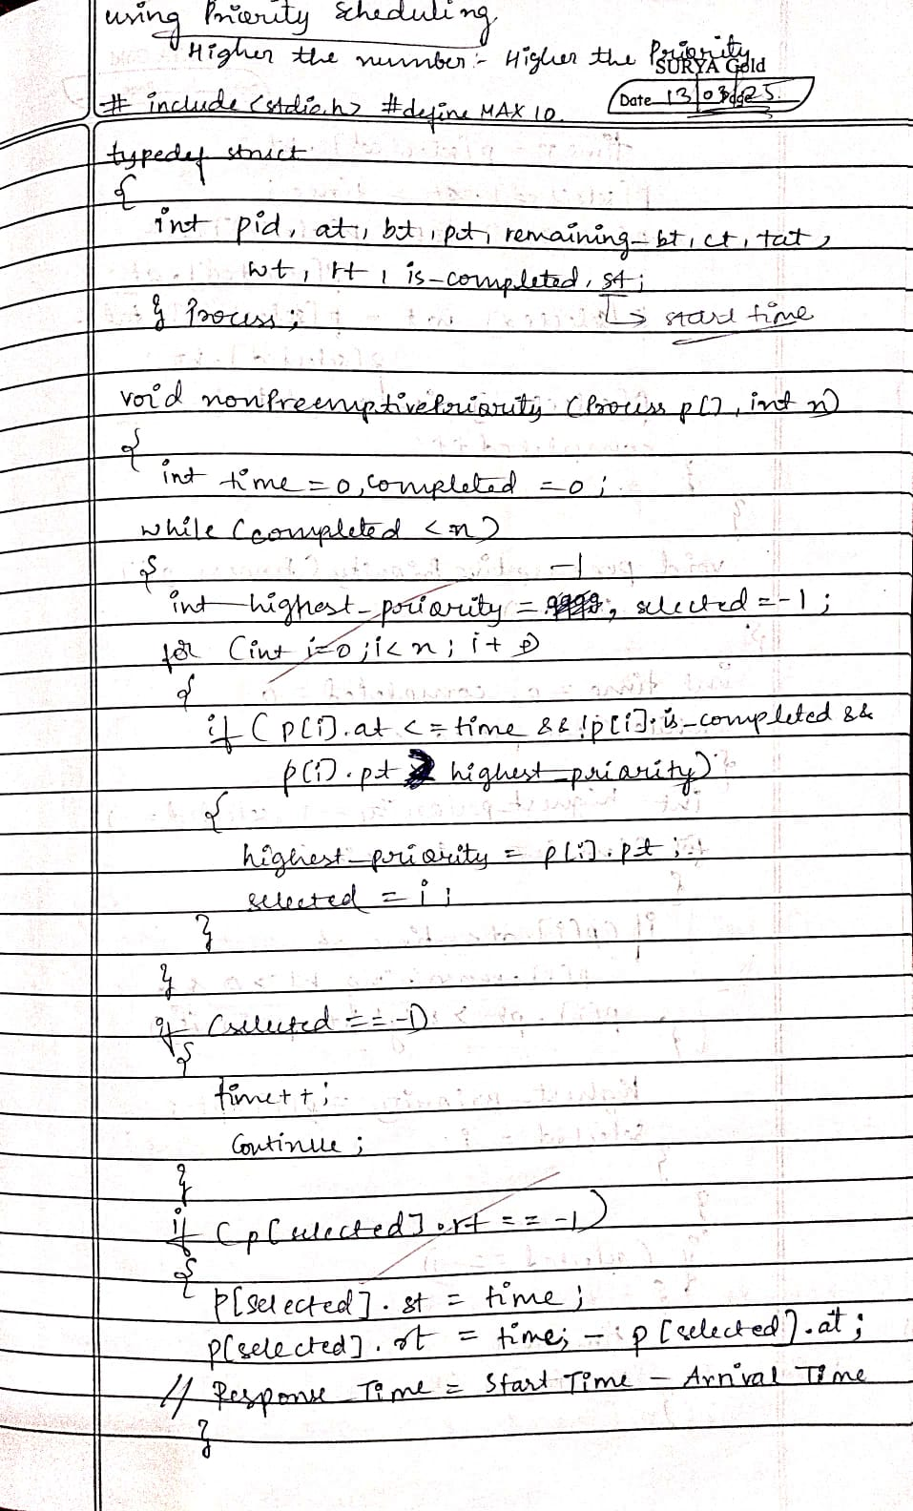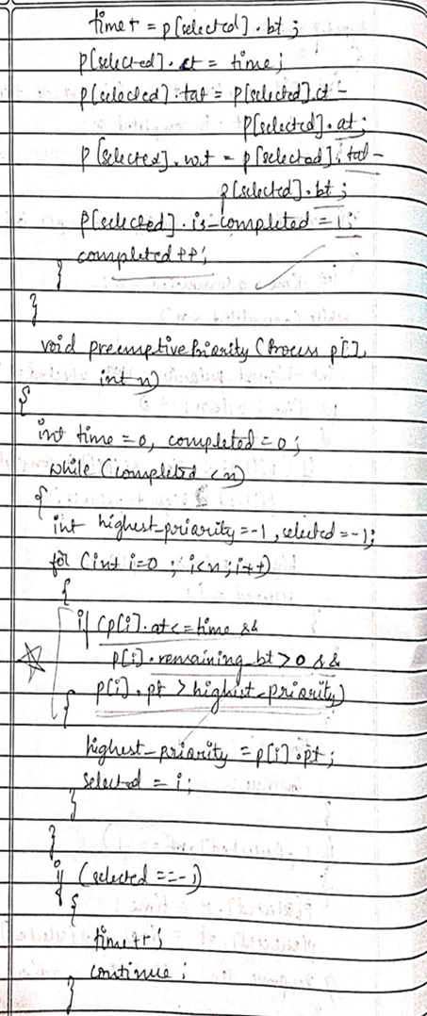

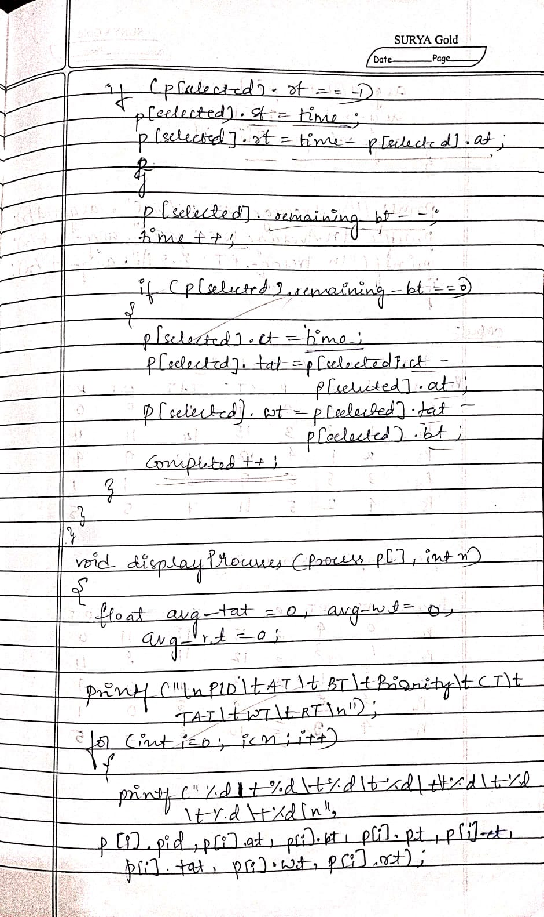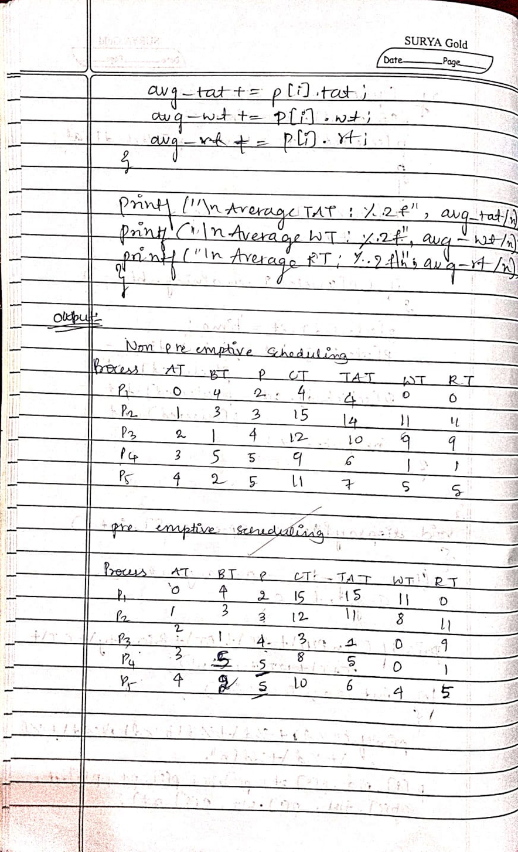

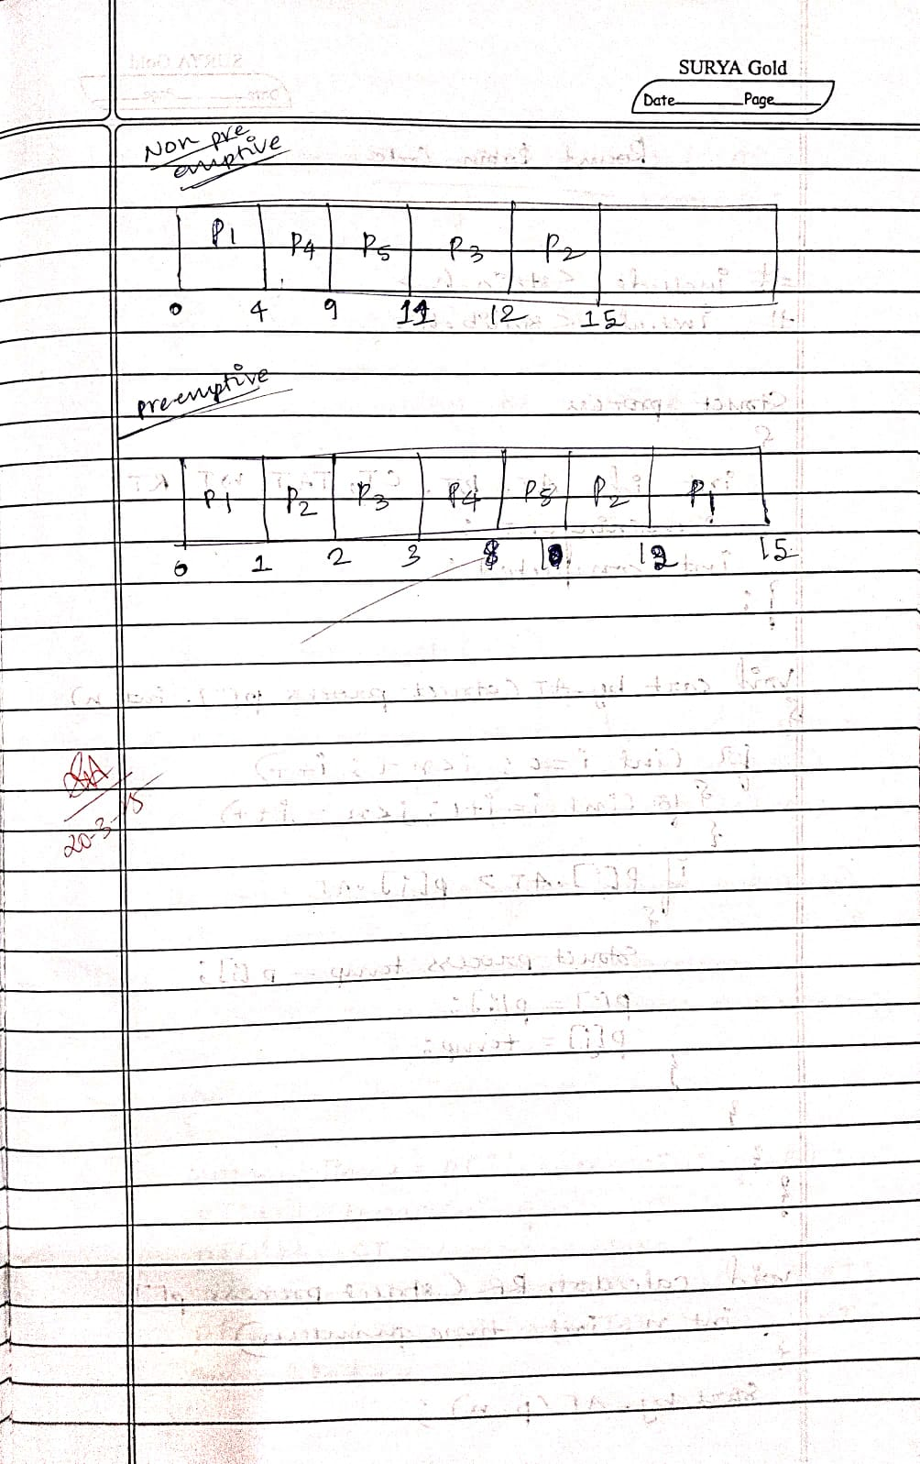

//round robin code

#include <stdio.h>

#include <stdlib.h>

struct process {

int id, AT, BT, CT, TAT, WT, RT, remaining_BT;

int completed;

};

void sort_by_AT(struct process p[], int n) {

for (int i = 0; i < n - 1; i++) {

for (int j = i + 1; j < n; j++) {

if (p[i].AT > p[j].AT) {

struct process temp = p[i];

p[i] = p[j];

p[j] = temp;

}

}

}

}

void calculate_RR(struct process p[], int n, int time_quantum) {

sort_by_AT(p, n);

int currentTime = 0, completed = 0;

int queue[n], front = 0, rear = 0;

int visited[n];

for (int i = 0; i < n; i++) {

p[i].remaining_BT = p[i].BT;

visited[i] = 0;

}

queue[rear++] = 0;

visited[0] = 1;

while (completed < n) {

int idx = queue[front++];

if (p[idx].remaining_BT == p[idx].BT)

p[idx].RT = currentTime - p[idx].AT;

if (p[idx].remaining_BT > time_quantum) {

currentTime += time_quantum;

p[idx].remaining_BT -= time_quantum;

} else {

currentTime += p[idx].remaining_BT;

p[idx].remaining_BT = 0;

p[idx].CT = currentTime;

p[idx].TAT = p[idx].CT - p[idx].AT;

p[idx].WT = p[idx].TAT - p[idx].BT;

completed++;

}

for (int i = 0; i < n; i++) {

if (!visited[i] && p[i].AT <= currentTime && p[i].remaining_BT > 0) {

queue[rear++] = i;

visited[i] = 1;

}

}

if (p[idx].remaining_BT > 0)

queue[rear++] = idx;

}

}

void display(struct process p[], int n) {

printf("\nProcess\tAT\tBT\tCT\tTAT\tWT\tRT\n");

for (int i = 0; i < n; i++) {

printf("%d\t%d\t%d\t%d\t%d\t%d\t%d\n", p[i].id, p[i].AT, p[i].BT, p[i].CT, p[i].TAT, p[i].WT, p[i].RT);

}

}

int main() {

int n, choice, time_quantum;

printf("Enter number of processes: ");

scanf("%d", &n);

struct process p[n];

for (int i = 0; i < n; i++) {

p[i].id = i + 1;

printf("Enter Arrival Time (AT) for process %d: ", i + 1);

scanf("%d", &p[i].AT);

printf("Enter Burst Time (BT) for process %d: ", i + 1);

scanf("%d", &p[i].BT);

p[i].completed = 0;

}

printf("Enter Time Quantum: ");

scanf("%d", &time_quantum);

calculate_RR(p, n, time_quantum);

display(p, n);

return 0;

}

Output:

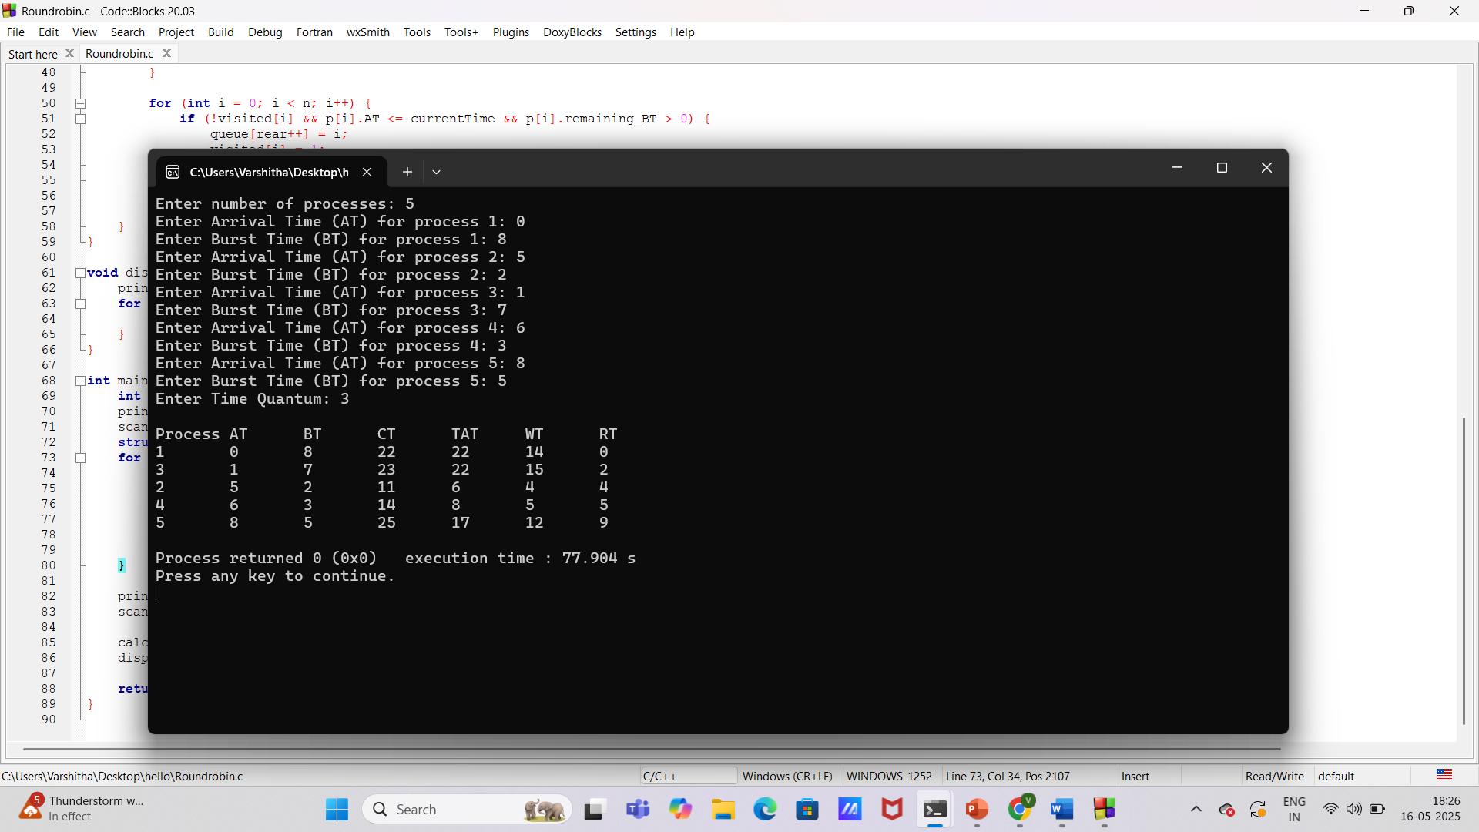

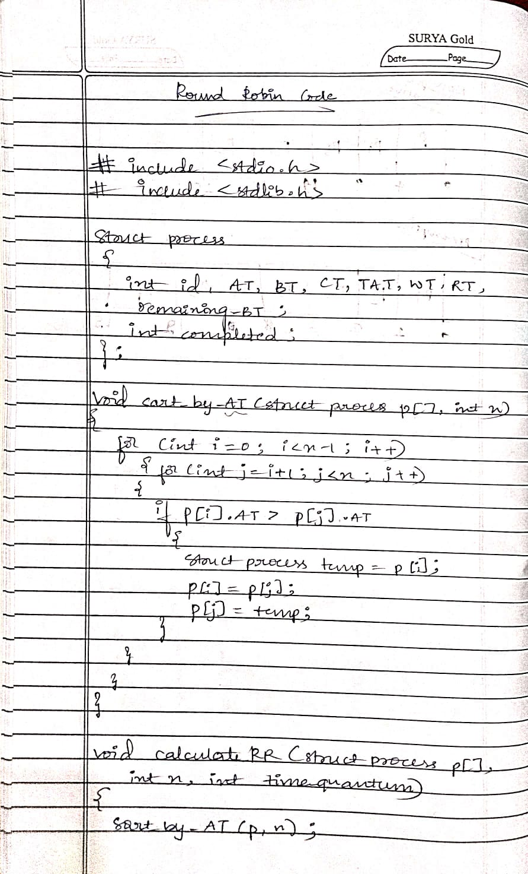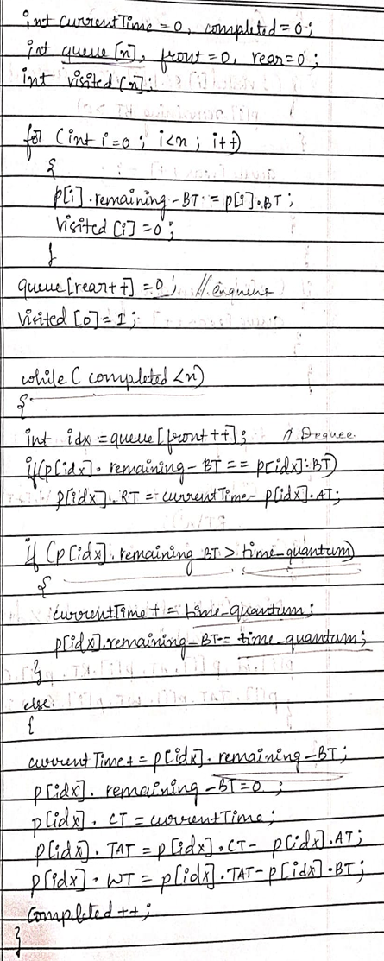

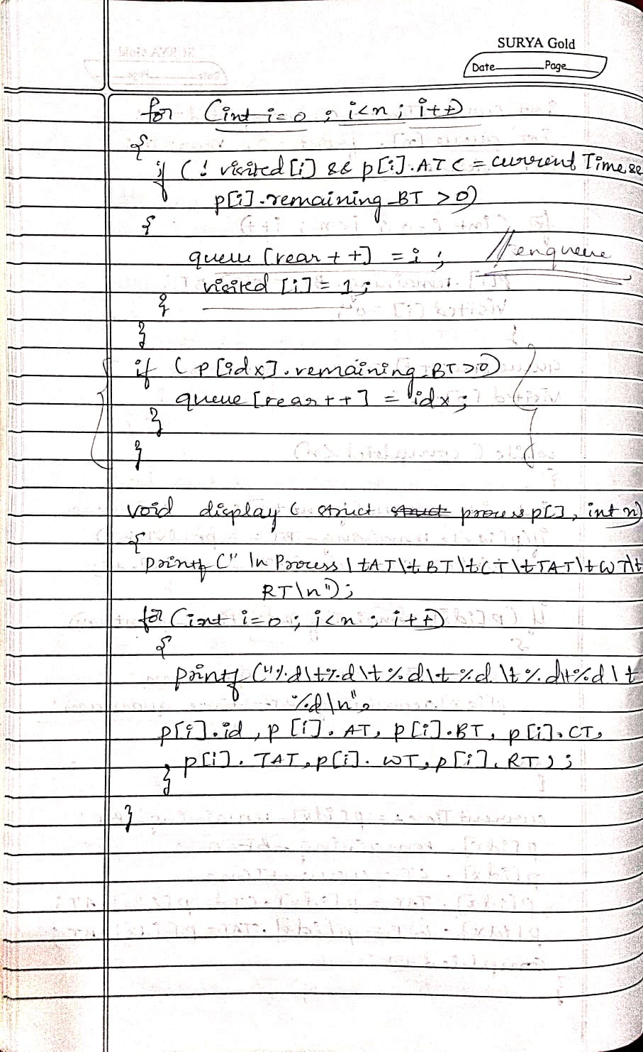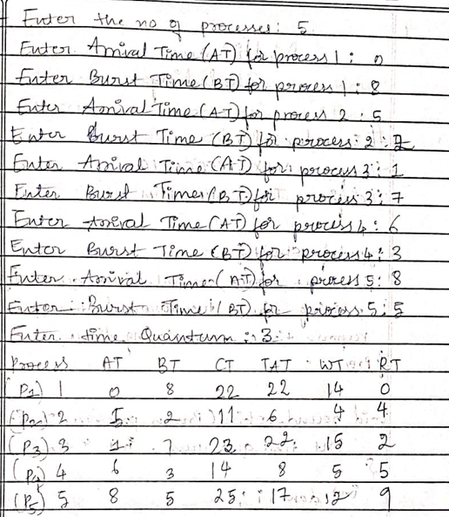

Program -3

Question:

Write a C program to simulate multi-level queue scheduling algorithm considering the following scenario. All the processes in the system are divided into two categories – system processes and user processes. System processes are to be given higher priority than user processes. Use FCFS scheduling for the processes in each queue.

Code:

#include <stdio.h>

#define MAX_PROCESSES 10

#define TIME_QUANTUM 2

typedef struct {

int burst_time, arrival_time, queue_type, waiting_time, turnaround_time, response_time, remaining_time;

} Process;

void round_robin(Process processes[], int n, int time_quantum, int *time) {

int done, i;

do {

done = 1;

for (i = 0; i < n; i++) {

if (processes[i].remaining_time > 0) {

done = 0;

if (processes[i].remaining_time > time_quantum) {

*time += time_quantum;

processes[i].remaining_time -= time_quantum;

} else {

*time += processes[i].remaining_time;

processes[i].waiting_time = *time - processes[i].arrival_time - processes[i].burst_time;

processes[i].turnaround_time = *time - processes[i].arrival_time;

processes[i].response_time = processes[i].waiting_time;

processes[i].remaining_time = 0;

}

}

}

} while (!done);

}

void fcfs(Process processes[], int n, int *time) {

for (int i = 0; i < n; i++) {

if (*time < processes[i].arrival_time) {

*time = processes[i].arrival_time;

}

processes[i].waiting_time = *time - processes[i].arrival_time;

processes[i].turnaround_time = processes[i].waiting_time + processes[i].burst_time;

processes[i].response_time = processes[i].waiting_time;

*time += processes[i].burst_time;

}

}

int main() {

Process processes[MAX_PROCESSES], system_queue[MAX_PROCESSES], user_queue[MAX_PROCESSES];

int n, sys_count = 0, user_count = 0, time = 0;

float avg_waiting = 0, avg_turnaround = 0, avg_response = 0, throughput;

printf("Enter number of processes: ");

scanf("%d", &n);

for (int i = 0; i < n; i++) {

printf("Enter Burst Time, Arrival Time and Queue of P%d: ", i + 1);

scanf("%d %d %d", &processes[i].burst_time, &processes[i].arrival_time, &processes[i].queue_type);

processes[i].remaining_time = processes[i].burst_time;

if (processes[i].queue_type == 1) {

system_queue[sys_count++] = processes[i];

} else {

user_queue[user_count++] = processes[i];

}

}

// Sort user processes by arrival time for FCFS

for (int i = 0; i < user_count - 1; i++) {

for (int j = 0; j < user_count - i - 1; j++) {

if (user_queue[j].arrival_time > user_queue[j + 1].arrival_time) {

Process temp = user_queue[j];

user_queue[j] = user_queue[j + 1];

user_queue[j + 1] = temp;

}

}

}

printf("\nQueue 1 is System Process\nQueue 2 is User Process\n");

round_robin(system_queue, sys_count, TIME_QUANTUM, &time);

fcfs(user_queue, user_count, &time);

printf("\nProcess Waiting Time Turn Around Time Response Time\n");

for (int i = 0; i < sys_count; i++) {

avg_waiting += system_queue[i].waiting_time;

avg_turnaround += system_queue[i].turnaround_time;

avg_response += system_queue[i].response_time;

printf("%d %d %d %d\n", i + 1, system_queue[i].waiting_time, system_queue[i].turnaround_time, system_queue[i].response_time);

}

for (int i = 0; i < user_count; i++) {

avg_waiting += user_queue[i].waiting_time;

avg_turnaround += user_queue[i].turnaround_time;

avg_response += user_queue[i].response_time;

printf("%d %d %d %d\n", i + 1 + sys_count, user_queue[i].waiting_time, user_queue[i].turnaround_time, user_queue[i].response_time);

}

avg_waiting /= n;

avg_turnaround /= n;

avg_response /= n;

throughput = (float)n / time;

printf("\nAverage Waiting Time: %.2f", avg_waiting);

printf("\nAverage Turn Around Time: %.2f", avg_turnaround);

printf("\nAverage Response Time: %.2f", avg_response);

printf("\nThroughput: %.2f", throughput);

printf("\nProcess returned %d (0x%d) execution time: %.3f s\n", time, time, (float)time);

return 0;

}

Output:

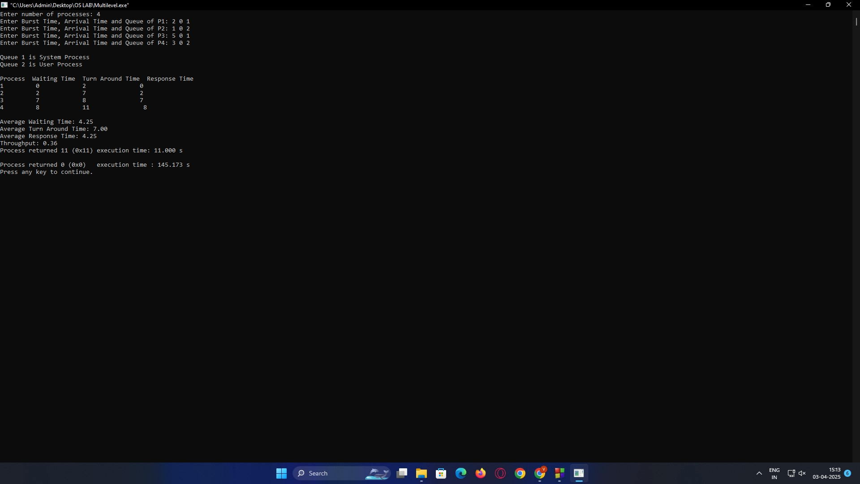

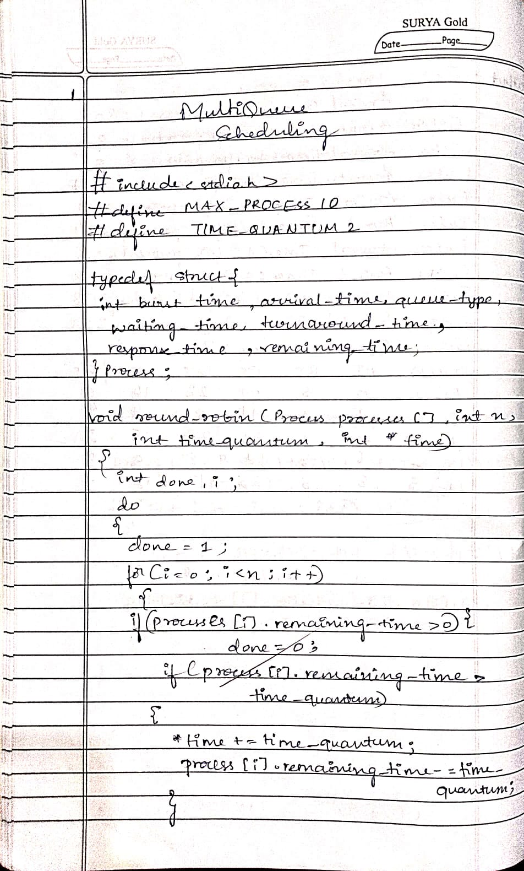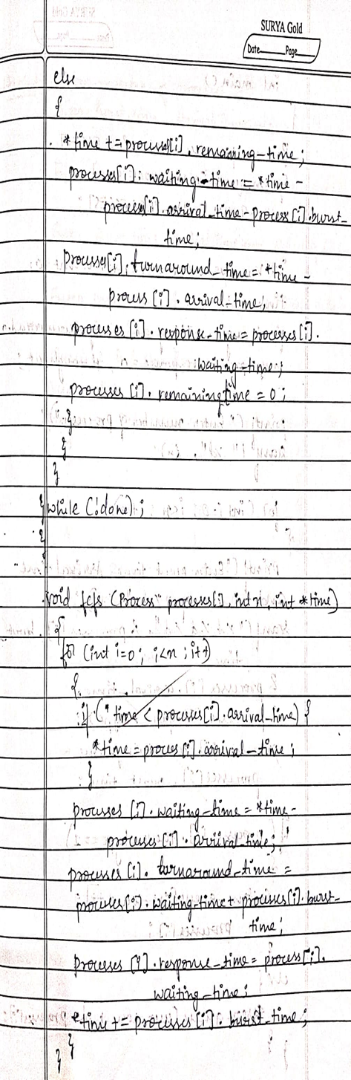

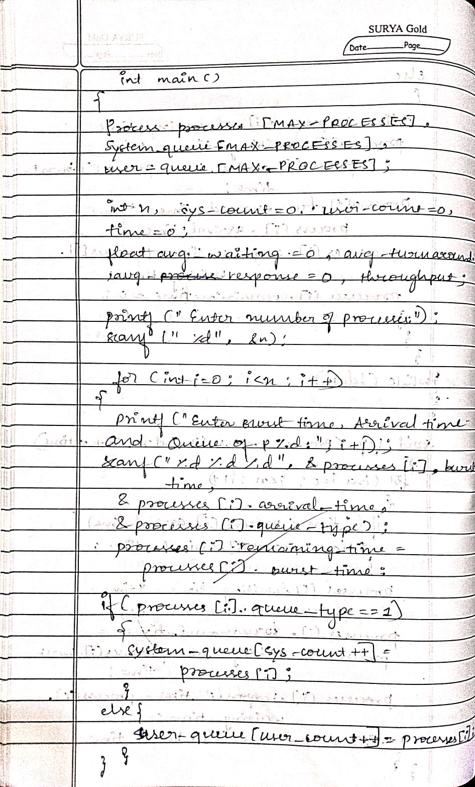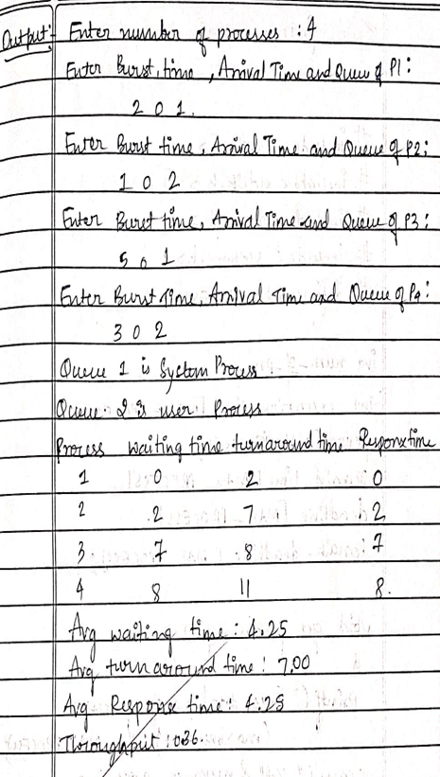

Program -4

Question:

Write a C program to simulate Real-Time CPU Scheduling algorithms:

1. Rate- Monotonic
2. Earliest-deadline First

a)

Code:

// Rate Monotonic

#include <stdio.h>

#include <stdlib.h>

#include <math.h>

#include <stdbool.h>

#define MAX_PROCESS 10

int num_of_process

int execution_time[MAX_PROCESS], period[MAX_PROCESS],

remain_time[MAX_PROCESS], deadline[MAX_PROCESS],

remain_deadline[MAX_PROCESS];

void get_process_info() {

printf("Enter total number of processes (maximum %d): ", MAX_PROCESS);

scanf("%d", &num_of_process);

if (num_of_process < 1) {

exit(0);

}

for (int i = 0; i < num_of_process; i++) {

printf("\nProcess %d:\n", i + 1);

printf("==> Execution time: ");

scanf("%d", &execution_time[i]);

remain_time[i] = execution_time[i];

printf("==> Period: ");

scanf("%d", &period[i]);

}

}

int max(int a, int b, int c) {

int max;

if (a >= b && a >= c)

max = a;

else if (b >= a && b >= c)

max = b;

else if (c >= a && c >= b)

max = c;

return max;

}

void print_schedule(int process_list[], int cycles) {

printf("\nScheduling:\n\n");

printf("Time: ");

for (int i = 0; i < cycles; i++) {

if (i < 10)

printf("| 0%d ", i);

else

printf("| %d ", i);

}

printf("|\n");

for (int i = 0; i < num_of_process; i++) {

printf("P[%d]: ", i + 1);

for (int j = 0; j < cycles; j++) {

if (process_list[j] == i + 1)

printf("|####");

else

printf("| ");

}

printf("|\n");

}

}

void rate_monotonic(int time) {

int process_list[100] = {0}, min = 999, next_process = 0;

float utilization = 0;

for (int i = 0; i < num_of_process; i++) {

utilization += (1.0 * execution_time[i]) / period[i];

}

int n = num_of_process;

float m = n * (pow(2, 1.0 / n) - 1);

if (utilization > m) {

printf("\nGiven problem is not schedulable under the said scheduling algorithm.\n");

}

for (int i = 0; i < time; i++) {

min = 1000;

for (int j = 0; j < num_of_process; j++) {

if (remain_time[j] > 0) {

if (min > period[j]) {

min = period[j];

next_process = j;

}

}

}

if (remain_time[next_process] > 0) {

process_list[i] = next_process + 1;

remain_time[next_process] -= 1;

}

for (int k = 0; k < num_of_process; k++) {

if ((i + 1) % period[k] == 0) {

remain_time[k] = execution_time[k];

next_process = k;

}

}

}

print_schedule(process_list, time);

}

int main() {

int observation_time;

get_process_info();

observation_time = max(period[0], period[1], period[2]);

rate_monotonic(observation_time);

return 0;

}

Output:

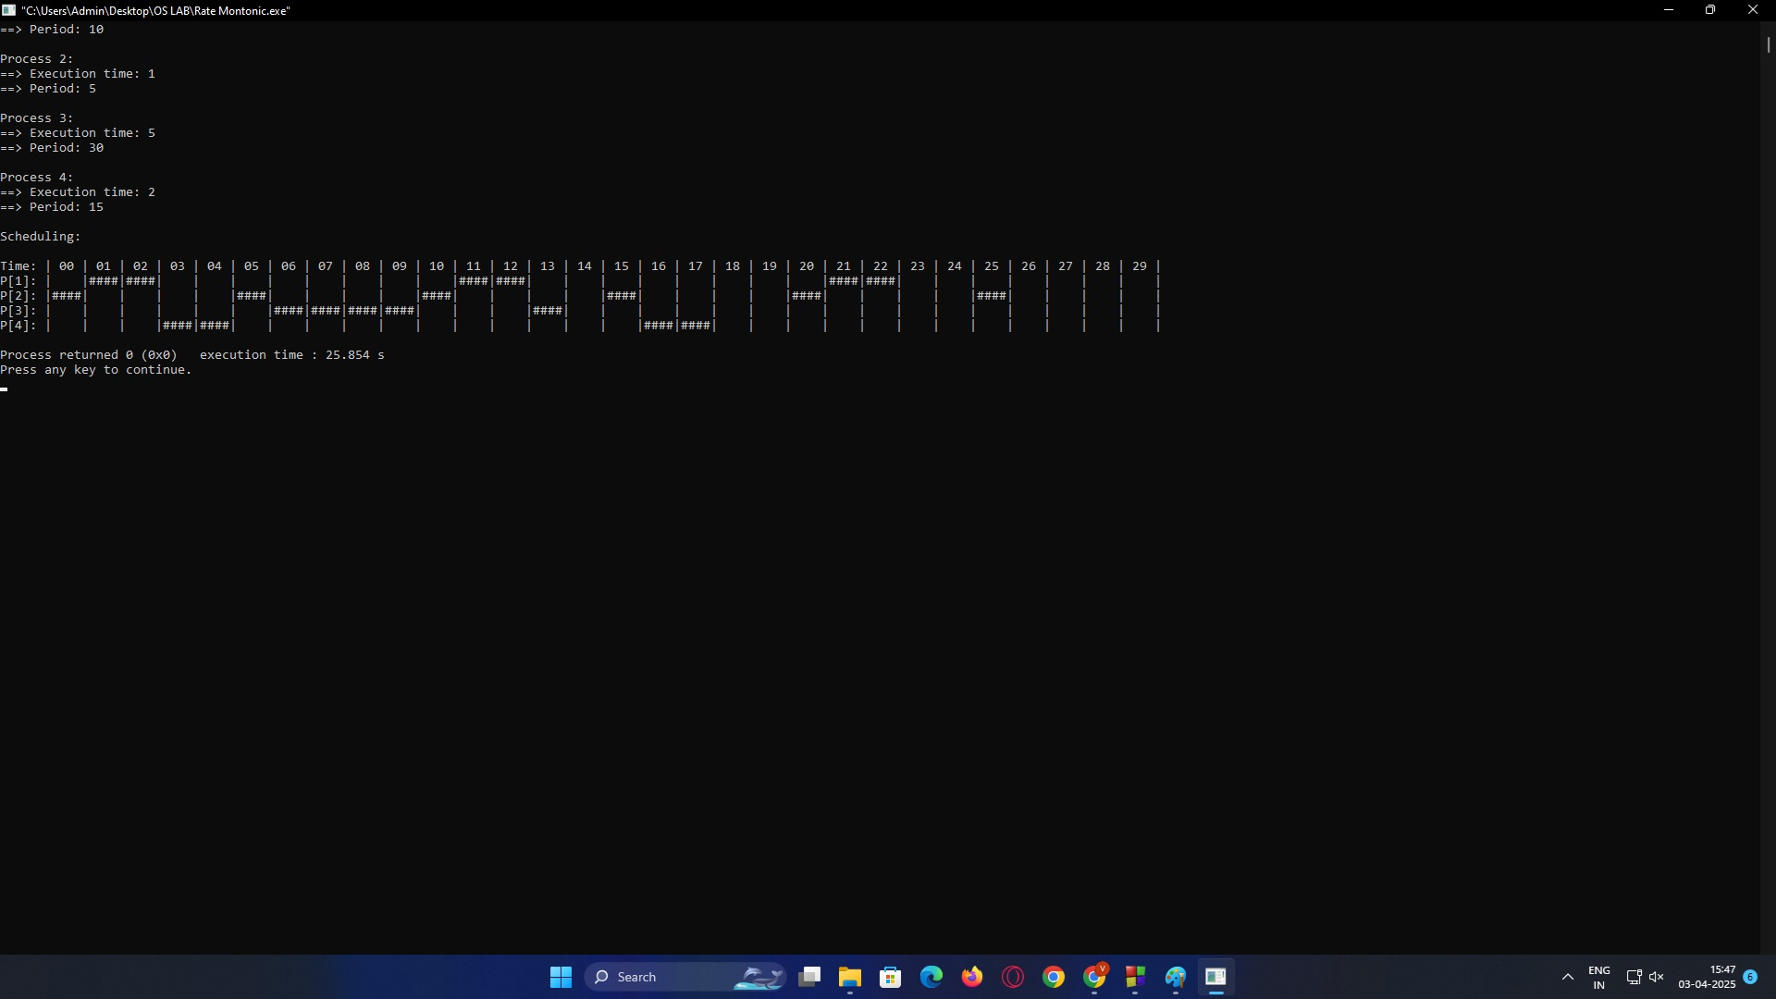

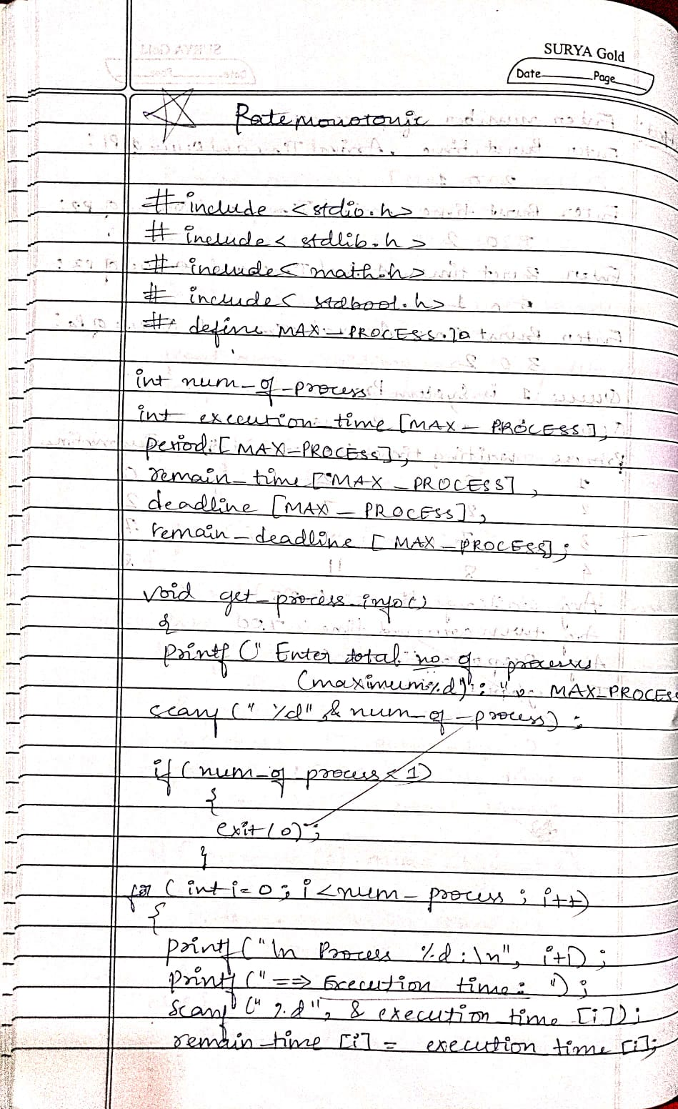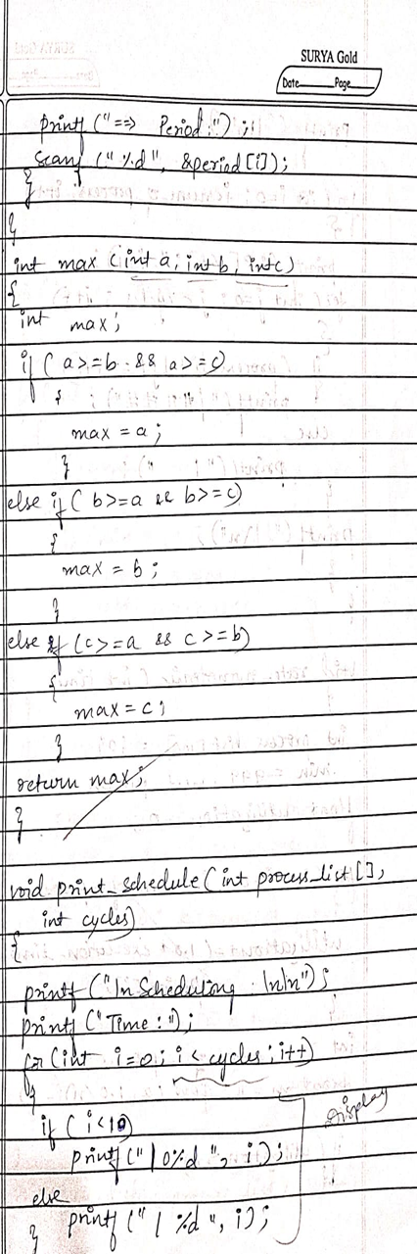

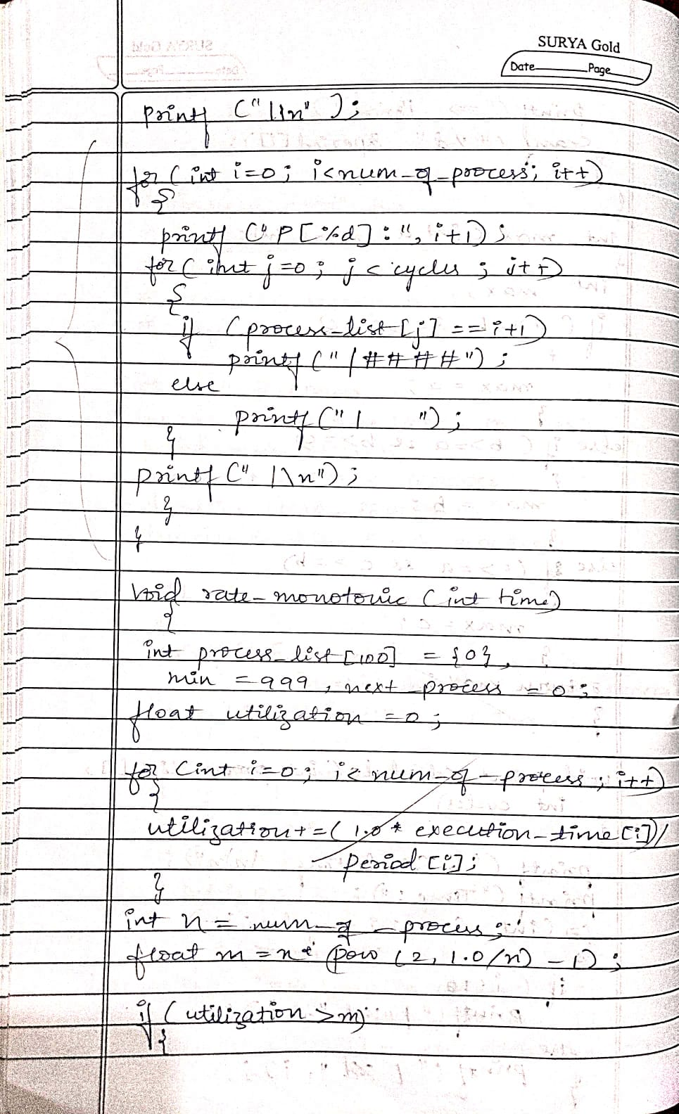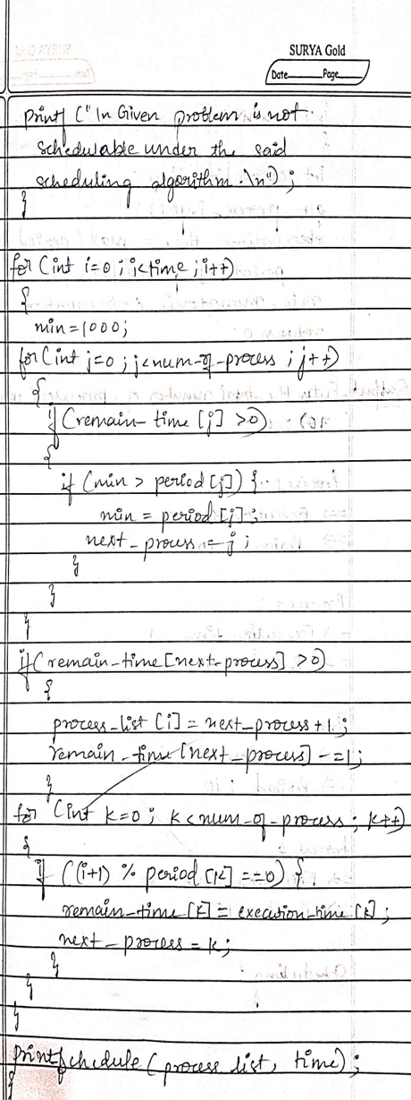

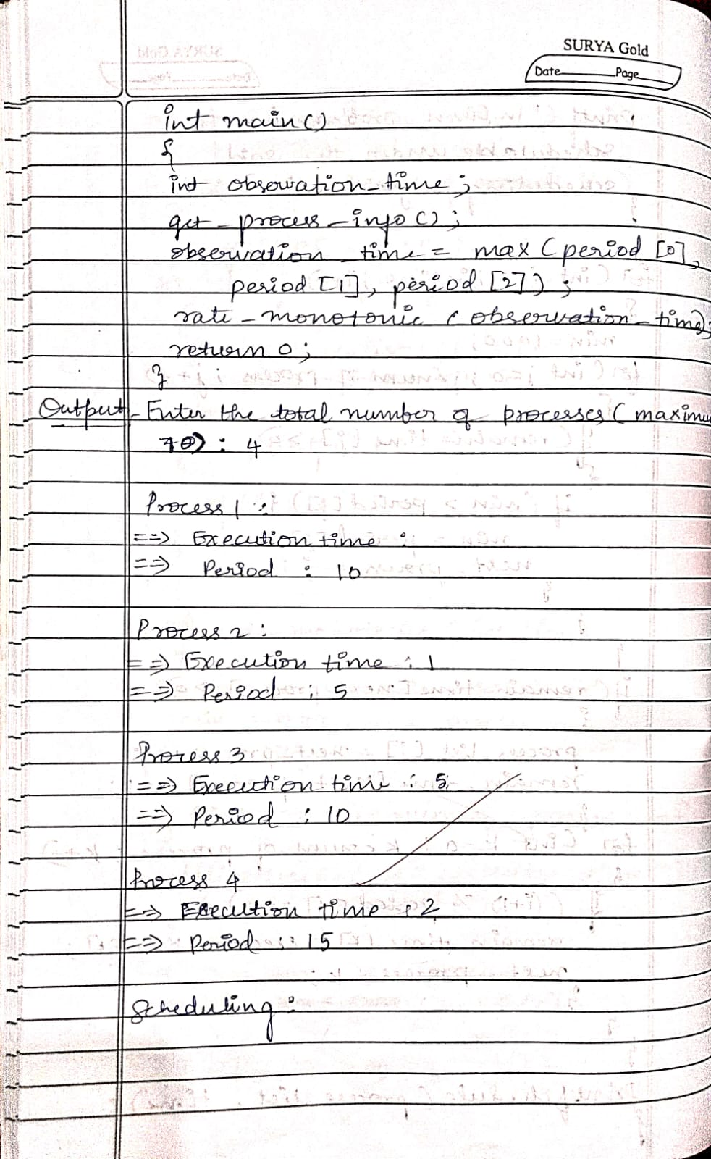

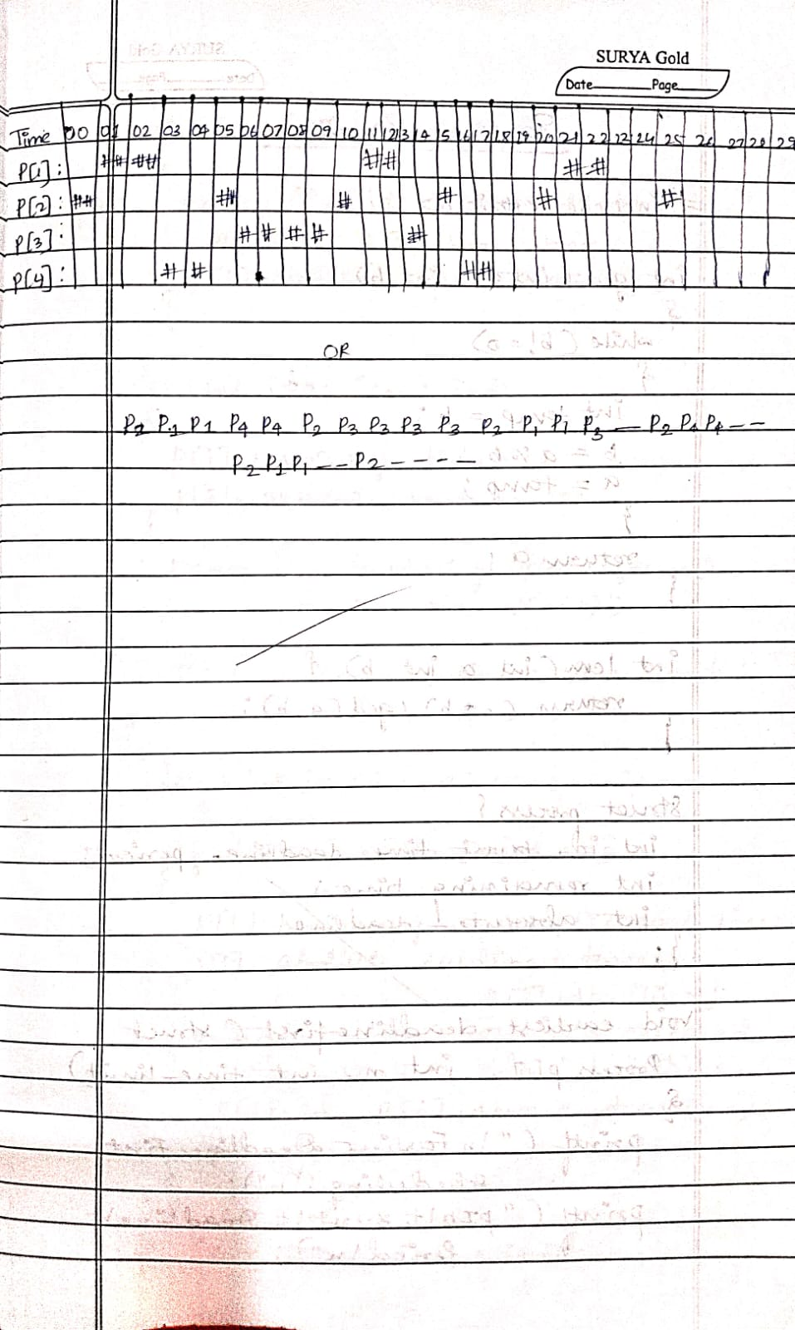

b)

// Earliest Deadline

#include <stdio.h>

int gcd(int a, int b) {

while (b != 0) {

int temp = b;

b = a % b;

a = temp;

}

return a;

}

int lcm(int a, int b) {

return (a * b) / gcd(a, b);

}

struct Process {

int id, burst_time, deadline, period;

int remaining_time;

int absolute_deadline;

};

void earliest_deadline_first(struct Process p[], int n, int time_limit) {

printf("\nEarliest Deadline First Scheduling:\n");

printf("PID\tBurst\tDeadline\tPeriod\n");

for (int i = 0; i < n; i++) {

printf("%d\t%d\t\t%d\t\t%d\n", p[i].id, p[i].burst_time, p[i].deadline, p[i].period);

}

// Initialization

for (int i = 0; i < n; i++) {

p[i].remaining_time = 0;

p[i].absolute_deadline = -1;

}

printf("\nScheduling occurs for %d ms:\n", time_limit);

for (int time = 0; time < time_limit; time++) {

// Release new jobs if period matches

for (int i = 0; i < n; i++) {

if (time % p[i].period == 0) {

p[i].remaining_time = p[i].burst_time;

p[i].absolute_deadline = time + p[i].deadline;

printf("%dms: Task %d released (Deadline at %dms)\n", time, p[i].id, p[i].absolute_deadline);

}

}

int earliest = -1;

for (int i = 0; i < n; i++) {

if (p[i].remaining_time > 0) {

if (earliest == -1 || p[i].absolute_deadline < p[earliest].absolute_deadline) {

earliest = i;

}

}

}

if (earliest != -1) {

printf("%dms: Task %d is running.\n", time, p[earliest].id);

p[earliest].remaining_time--;

} else {

printf("%dms: CPU is idle.\n", time);

}

}

}

int main() {

int n;

printf("Enter the number of processes: ");

scanf("%d", &n);

struct Process processes[n];

printf("Enter the CPU burst times:\n");

for (int i = 0; i < n; i++) {

printf("P[%d] burst time: ", i + 1);

scanf("%d", &processes[i].burst_time);

processes[i].id = i + 1;

}

printf("Enter the deadlines:\n");

for (int i = 0; i < n; i++) {

printf("P[%d] deadline: ", i + 1);

scanf("%d", &processes[i].deadline);

}

printf("Enter the time periods:\n");

for (int i = 0; i < n; i++) {

printf("P[%d] period: ", i + 1);

scanf("%d", &processes[i].period);}

int hyperperiod = processes[0].period;

for (int i = 1; i < n; i++) {

hyperperiod = lcm(hyperperiod, processes[i].period);

}

printf("\nSystem will execute for hyperperiod (LCM of periods): %d ms\n", hyperperiod);

earliest_deadline_first(processes, n, hyperperiod);

return 0;

}

Output:

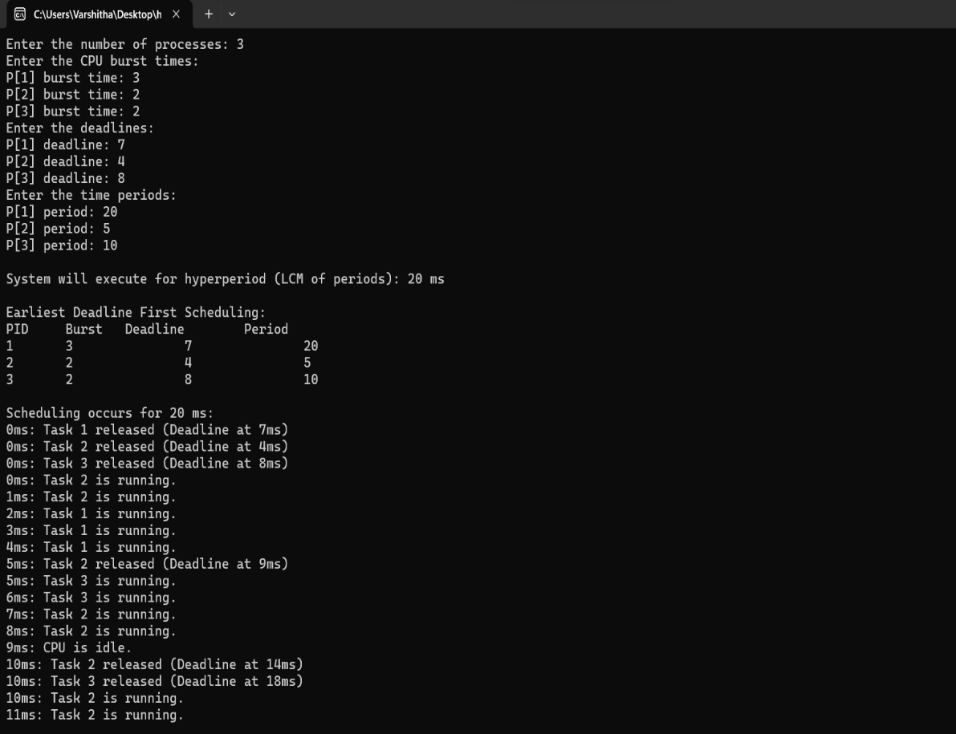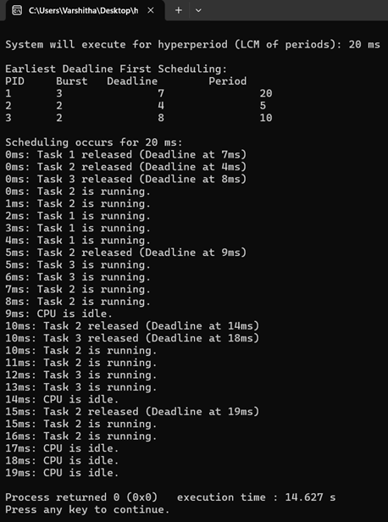

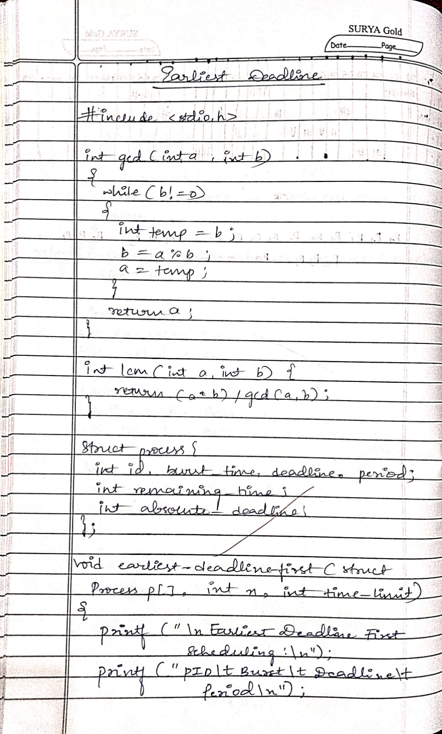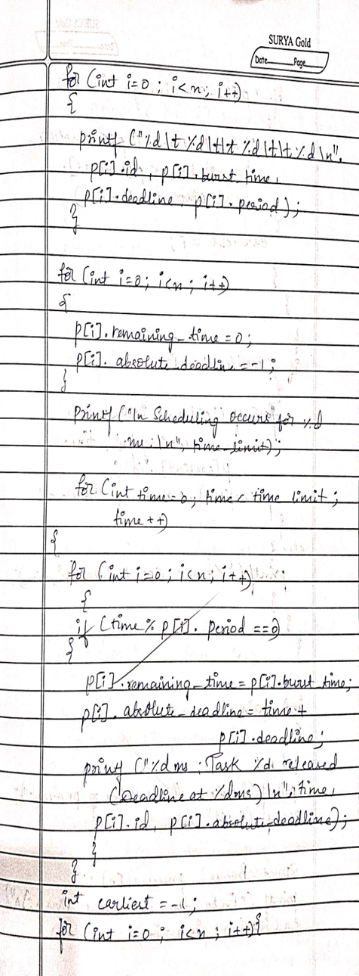

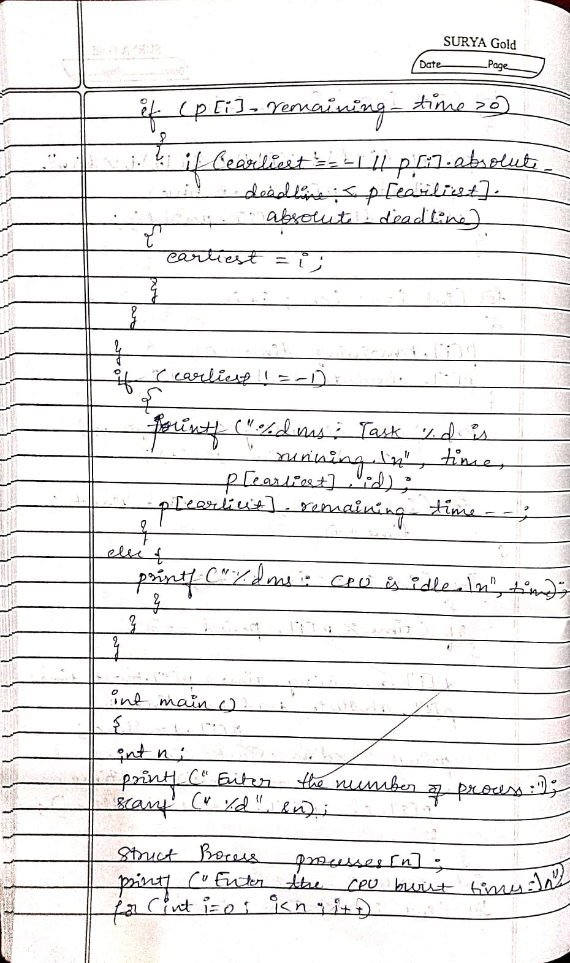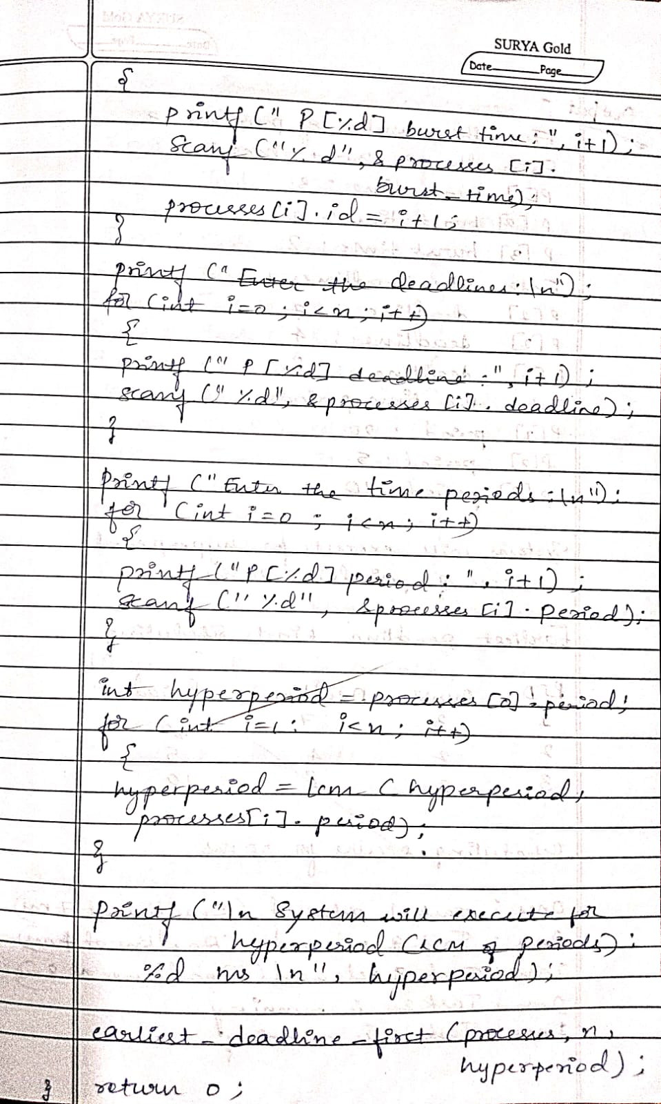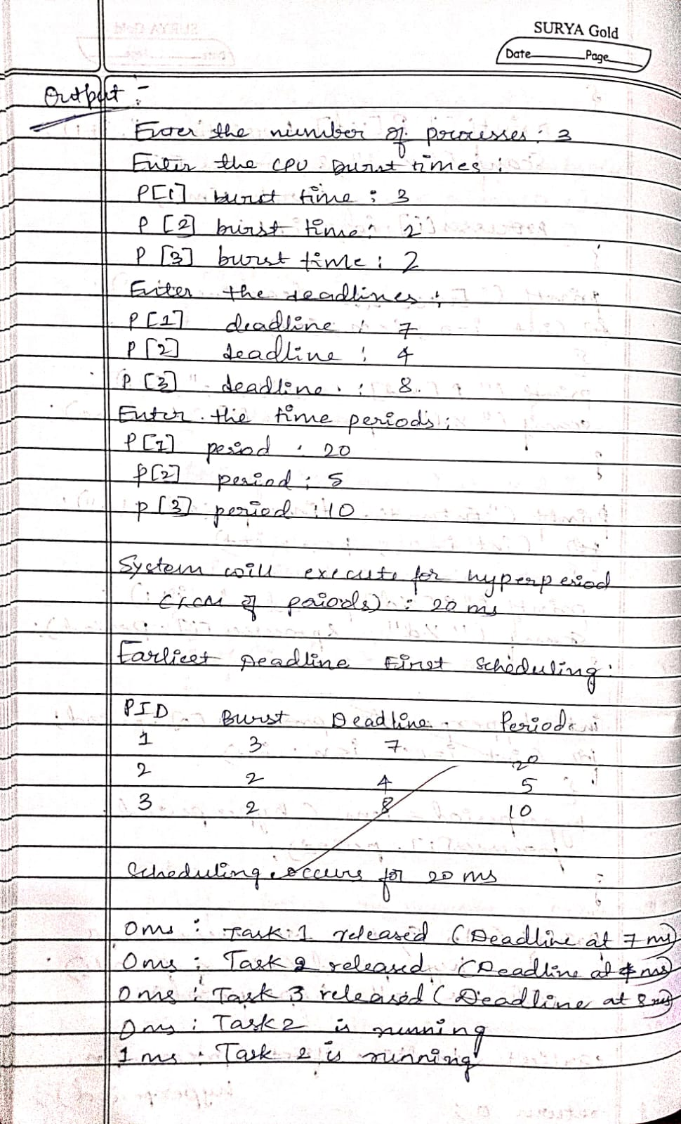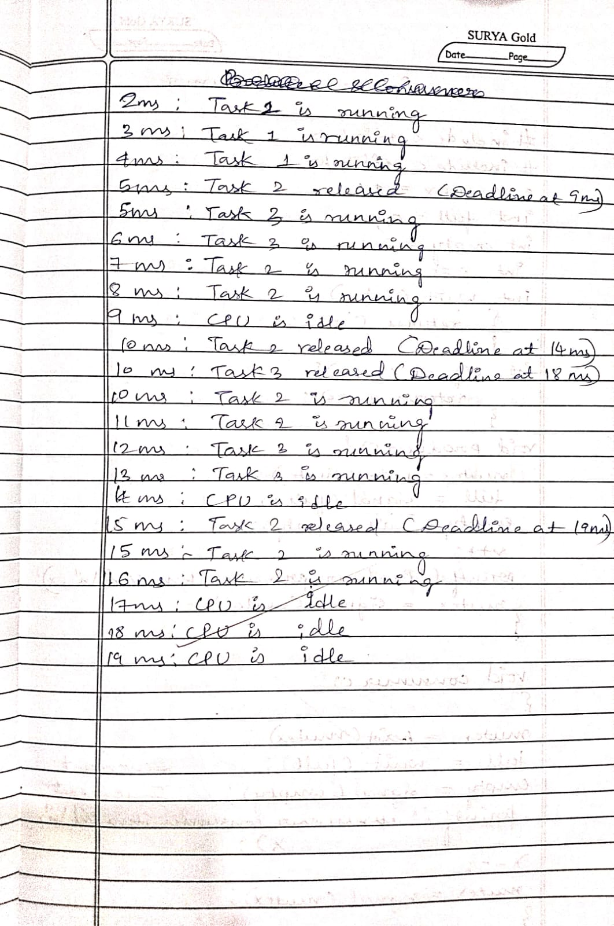

Program -5

Question:

Write a C program to simulate producer-consumer problem using semaphores.

Code:

#include <stdio.h>

#include <stdlib.h>

int mutex = 1;

int full = 0;

int empty = 3;

int x = 0;

int wait(int s) {

return (--s);

}

int signal(int s) {

return (++s);

}

void producer() {

mutex = wait(mutex);

full = signal(full);

empty = wait(empty);

x++;

printf("Producer produces item %d\n", x);

mutex = signal(mutex);

}

void consumer() {

mutex = wait(mutex);

full = wait(full);

empty = signal(empty);

printf("Consumer consumes item %d\n", x);

x--;

mutex = signal(mutex);

}

int main() {

int choice;

while (1) {

printf("\n1. Producer\n2. Consumer\n3. Exit\n");

printf("Enter your choice: ");

scanf("%d", &choice);

switch (choice) {

case 1:

if ((mutex == 1) && (empty != 0))

producer();

else

printf("Buffer is full!\n");

break;

case 2:

if ((mutex == 1) && (full != 0))

consumer();

else

printf("Buffer is empty!\n");

break;

case 3:

exit(0);

default:

printf("Invalid choice!\n");

}

}

return 0;

}

Output:

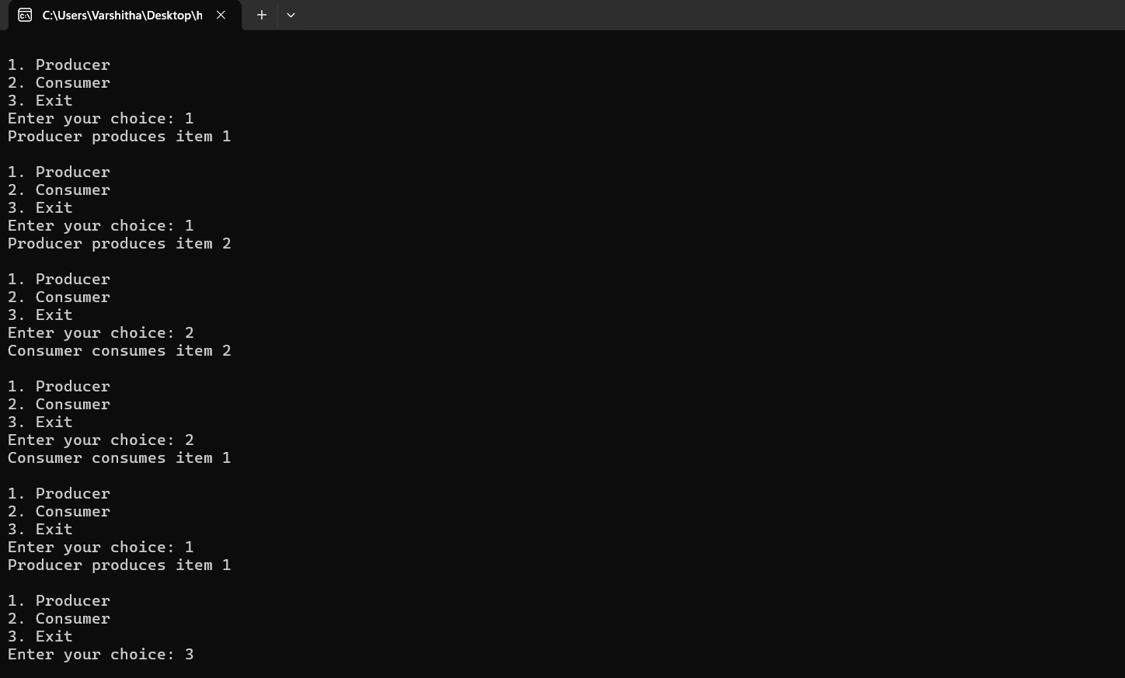

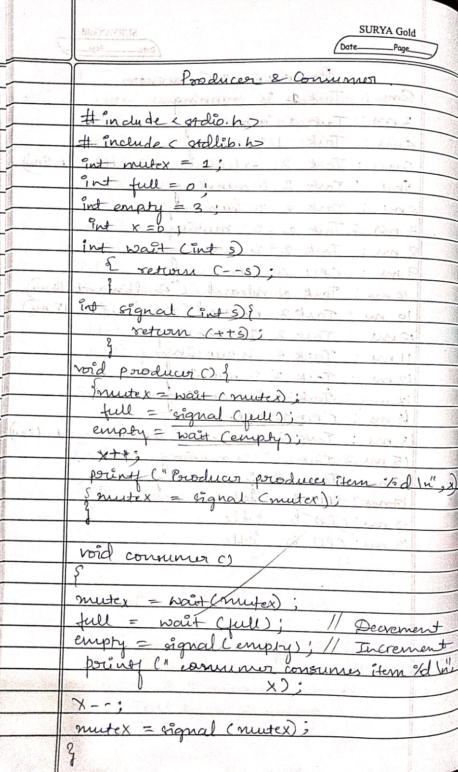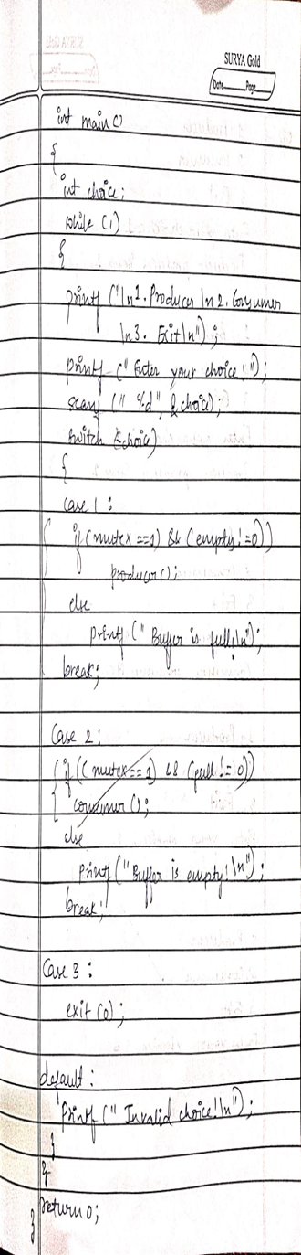

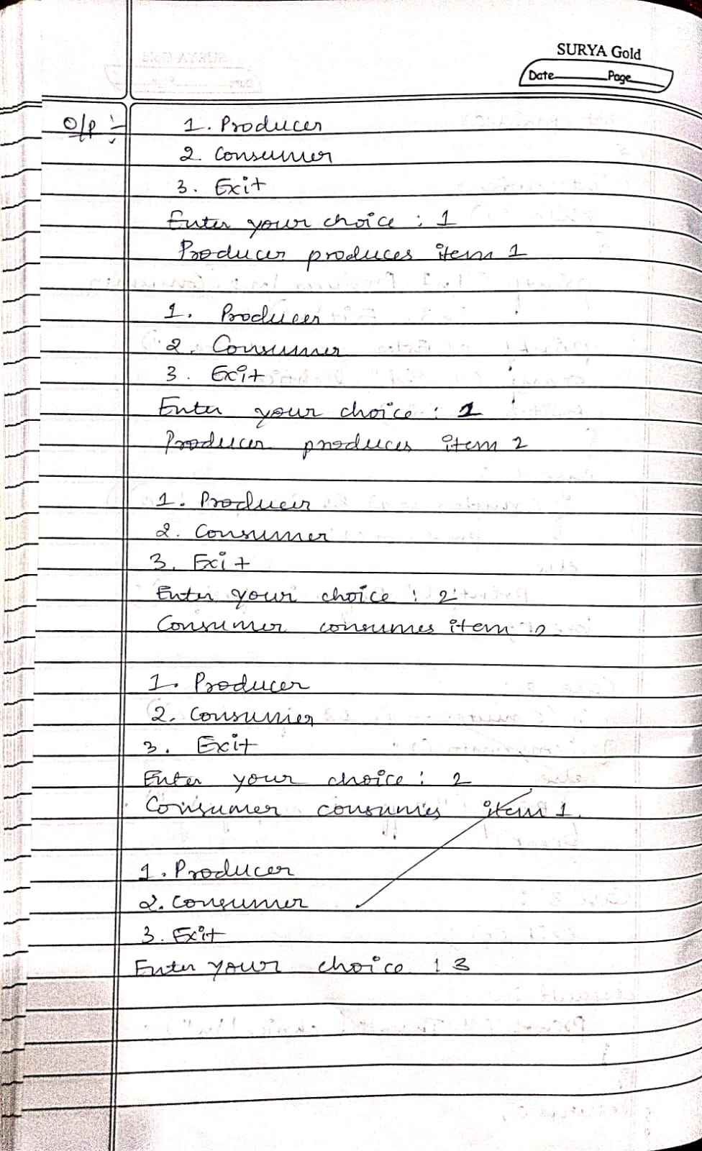

Program -6

Question

Write a C program to simulate the concept of Dining Philosophers problem.

Code

#include <stdio.h>

#include <stdlib.h>

#define MAX 10

int totalPhilosophers;

int hungry[MAX];

int areNeighbors(int a, int b) {

return (abs(a - b) == 1 || abs(a - b) == totalPhilosophers - 1);}

void option1(int count) {

printf("\nAllow one philosopher to eat at any time\n");

for (int i = 0; i < count; i++) {

printf("P %d is granted to eat\n", hungry[i]);

for (int j = 0; j < count; j++) {

if (j != i) {

printf("P %d is waiting\n", hungry[j]);

}

}

}

}

void option2(int count) {

printf("\nAllow two philosophers to eat at same time\n");

int combination = 1;

for (int i = 0; i < count; i++) {

for (int j = i + 1; j < count; j++) {

if (!areNeighbors(hungry[i], hungry[j])) {

printf("combination %d\n", combination++);

printf("P %d and P %d are granted to eat\n", hungry[i], hungry[j]);

for (int k = 0; k < count; k++) {

if (k != i && k != j) {

printf("P %d is waiting\n", hungry[k]);

}

}

printf("\n");

}

}

}

if (combination == 1) {

printf("No combinations found where two non-neighbor philosophers can eat.\n");

}

}

int main() {

int hungryCount;

printf("DINING PHILOSOPHER PROBLEM\n");

printf("Enter the total no. of philosophers: ");

scanf("%d", &totalPhilosophers);

printf("How many are hungry: ");

scanf("%d", &hungryCount);

for (int i = 0; i < hungryCount; i++) {

printf("Enter philosopher %d position: ", i + 1);

scanf("%d", &hungry[i]);

}

int choice;

do {

printf("\n1. One can eat at a time 2. Two can eat at a time 3. Exit\n");

printf("Enter your choice: ");

scanf("%d", &choice);

switch (choice) {

case 1:

option1(hungryCount);

break;

case 2:

option2(hungryCount);

break;

case 3:

printf("Exiting...\n");

break;

default:

printf("Invalid choice!\n");

}

} while (choice != 3);

return 0;

}

Output:

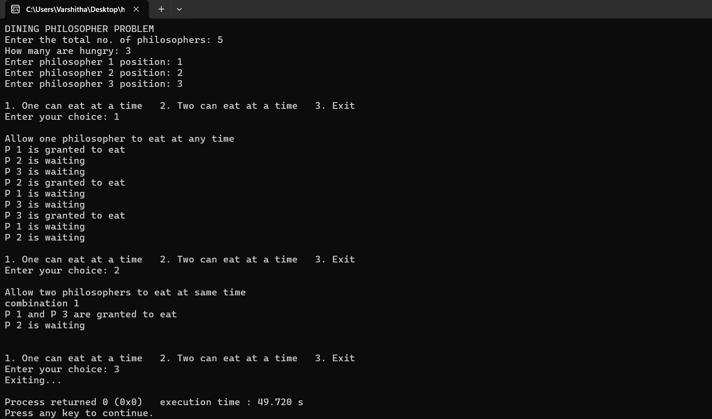

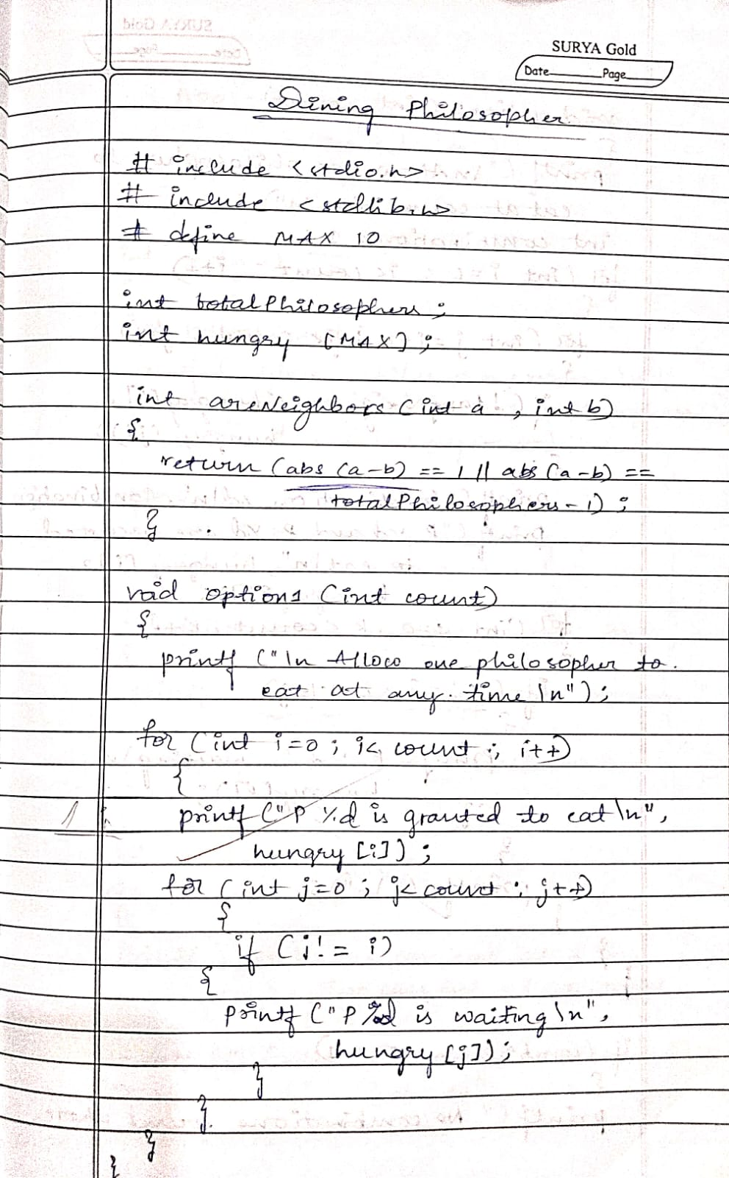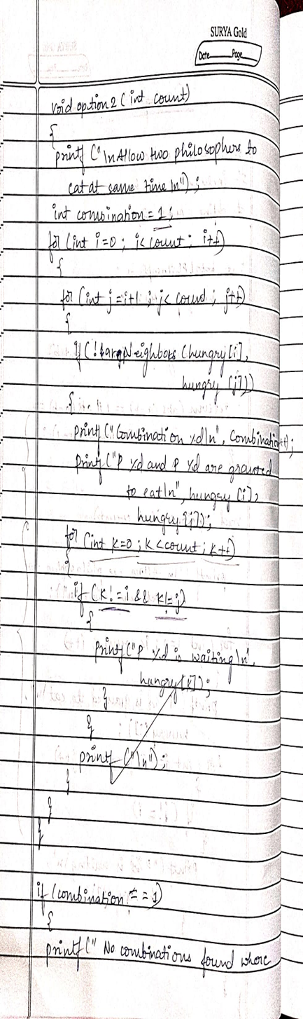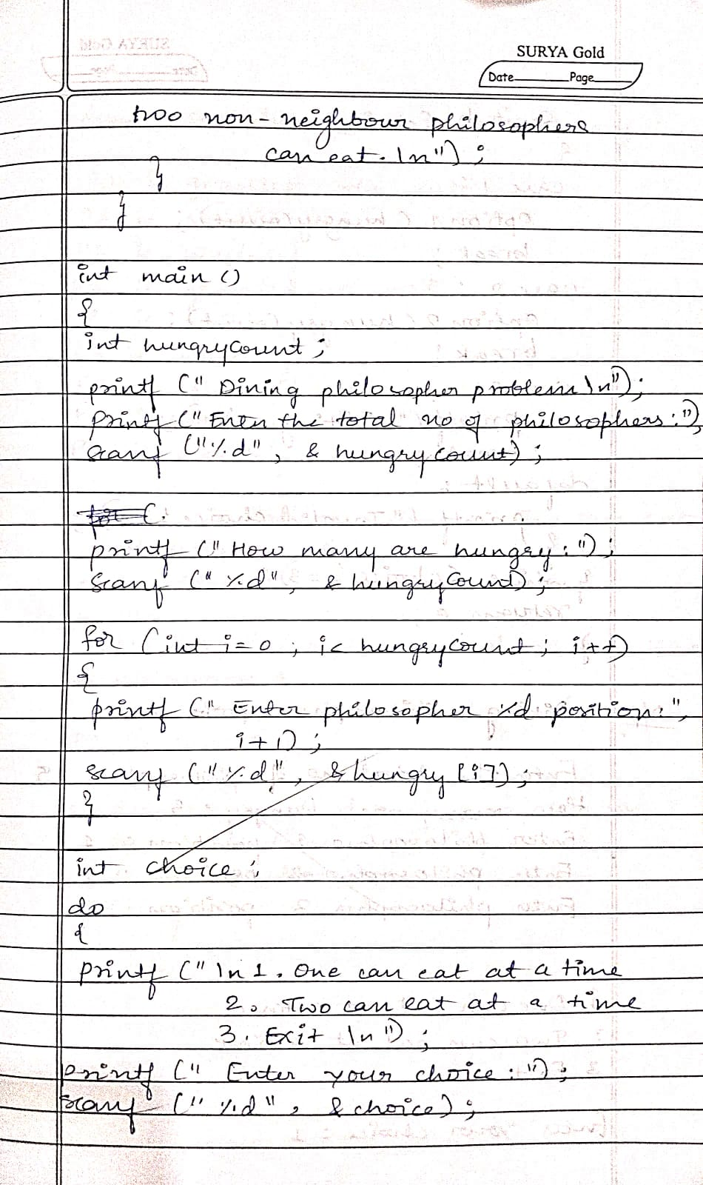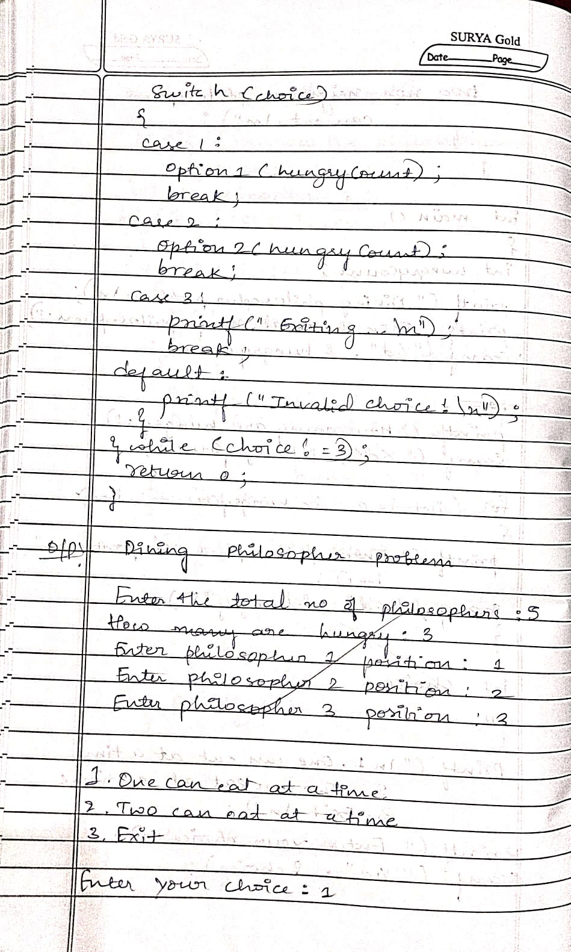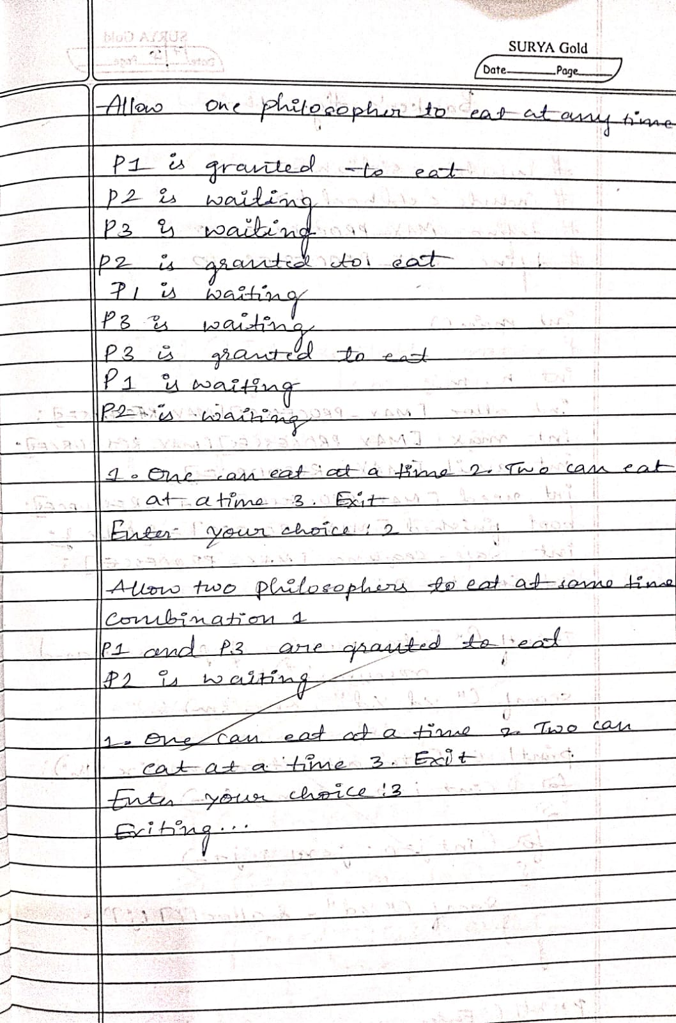

Program -7

Question

Write a C program to simulate Bankers algorithm for the purpose of deadlock avoidance.

Code:

#include <stdio.h>

#include <stdbool.h>

#define MAX 10

int main() {

int n, m, i, j, k;

int alloc[MAX][MAX], max[MAX][MAX], avail[MAX], need[MAX][MAX];

int finish[MAX] = {0}, safeSeq[MAX], work[MAX];

printf("Enter number of processes and resources:\n");

scanf("%d %d", &n, &m);

printf("Enter allocation matrix:\n");

for (i = 0; i < n; i++)

for (j = 0; j < m; j++)

scanf("%d", &alloc[i][j]);

printf("Enter maximum matrix:\n");

for (i = 0; i < n; i++)

for (j = 0; j < m; j++)

scanf("%d", &max[i][j]);

printf("Enter available matrix:\n");

for (i = 0; i < m; i++)

scanf("%d", &avail[i]);

for (i = 0; i < n; i++)

for (j = 0; j < m; j++)

need[i][j] = max[i][j] - alloc[i][j];

for (i = 0; i < m; i++)

work[i] = avail[i];

int count = 0;

bool found;

while (count < n) {

found = false;

for (i = 0; i < n; i++) {

if (!finish[i]) {

for (j = 0; j < m; j++) {

if (need[i][j] > work[j])

break;

}

if (j == m) {

for (k = 0; k < m; k++)

work[k] += alloc[i][k];

safeSeq[count++] = i;

finish[i] = 1;

found = true;

}

}

}

if (!found)

break;

}

if (count == n) {

printf("System is in safe state\n");

printf("Safe sequence is: ");

for (i = 0; i < n; i++) {

printf("P%d", safeSeq[i]);

if (i != n - 1)

printf(" -> ");

}

printf("\n");

} else {

printf("System is in unsafe state\n");

}

return 0;

}

Output:

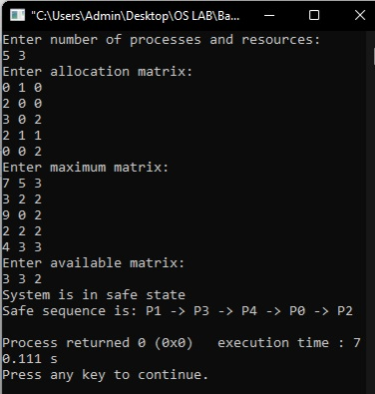

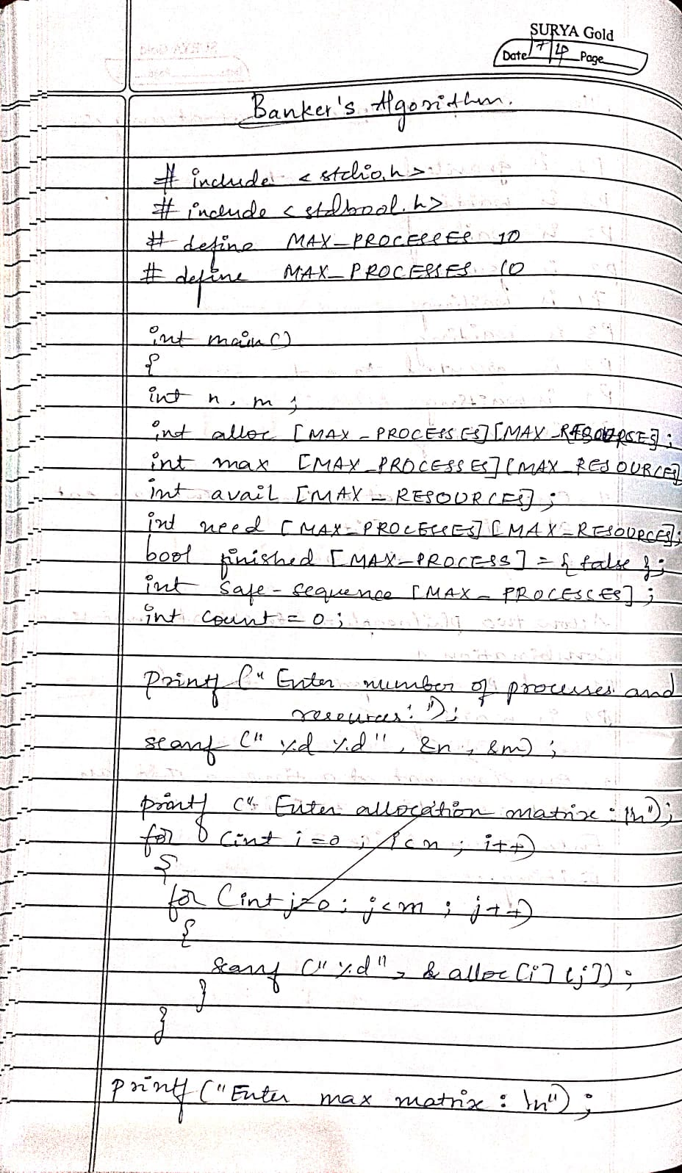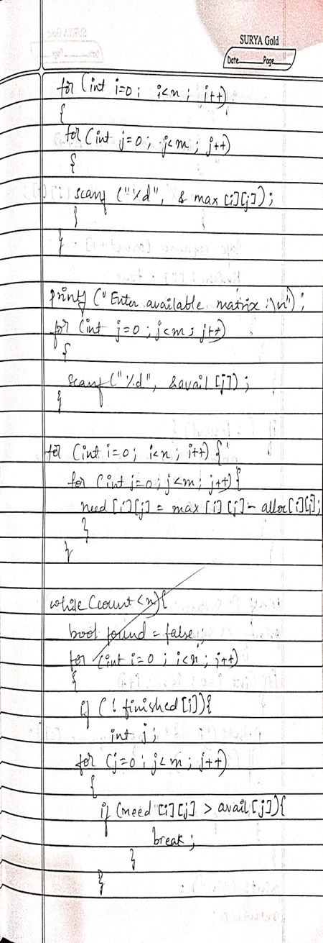

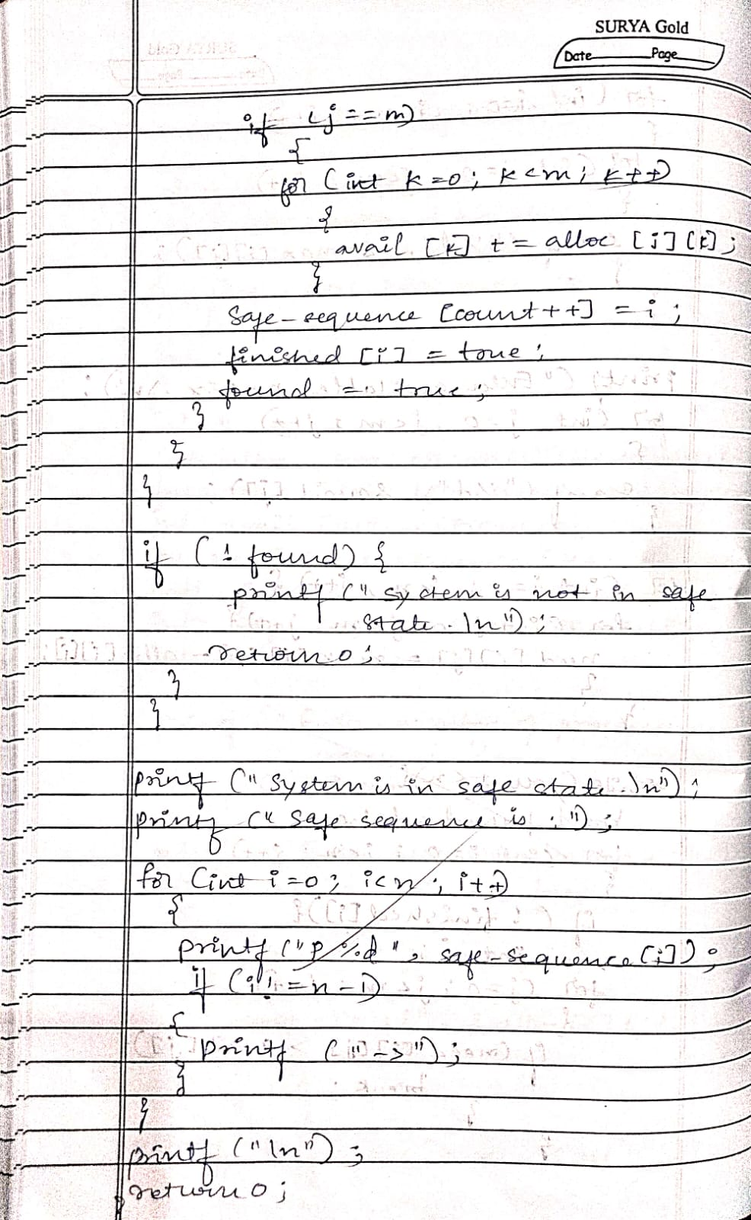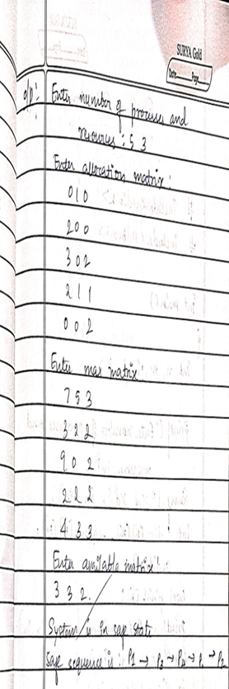

Program -8

Question

Write a C program to simulate deadlock detection.

Code

#include <stdio.h>

#include <stdbool.h>

int main() {

    int n, m, i, j, k;

    printf("Enter number of processes and resources:\n");

    scanf("%d %d", &n, &m);

    int alloc[n][m], request[n][m], avail[m];

    bool finish[n];

    printf("Enter allocation matrix:\n");

    for (i = 0; i < n; i++)

        for (j = 0; j < m; j++)

            scanf("%d", &alloc[i][j]);

    printf("Enter request matrix:\n");

    for (i = 0; i < n; i++)

        for (j = 0; j < m; j++)

            scanf("%d", &request[i][j]);

    printf("Enter available matrix:\n");

    for (i = 0; i < m; i++)

        scanf("%d", &avail[i]);

    for (i = 0; i < n; i++) {

        bool is_zero = true;

        for (j = 0; j < m; j++) {

            if (alloc[i][j] != 0) {

                is_zero = false;

                break;

            }

        }

        finish[i] = is_zero;

    }

    bool changed;

    do {

        changed = false;

        for (i = 0; i < n; i++) {

            if (!finish[i]) {

                bool can_finish = true;

                for (j = 0; j < m; j++) {

                    if (request[i][j] > avail[j]) {

                        can_finish = false;

                        break;

                    }

                }

                if (can_finish) {

                    for (k = 0; k < m; k++)

                        avail[k] += alloc[i][k];

                    finish[i] = true;

                    changed = true;

                    printf("Process %d can finish.\n", i);

                }

            }

        }

    } while (changed);

    bool deadlock = false;

    for (i = 0; i < n; i++) {

        if (!finish[i]) {

            deadlock = true;

            break;

        }

    }

    if (deadlock)

        printf("System is in a deadlock state.\n");

    else

        printf("System is not in a deadlock state.\n");

    return 0;

}

Output:

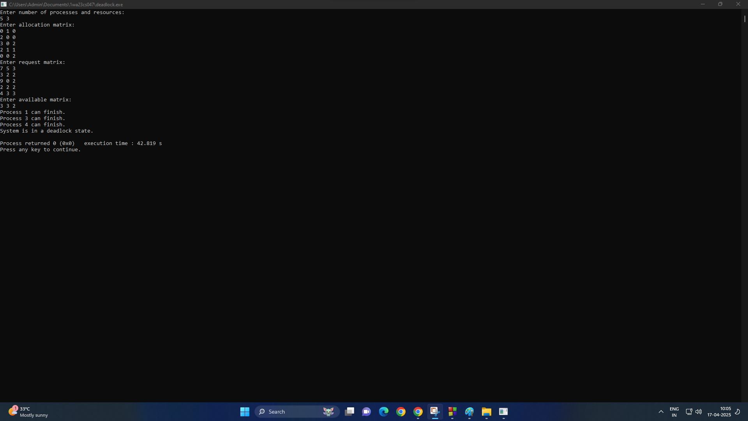

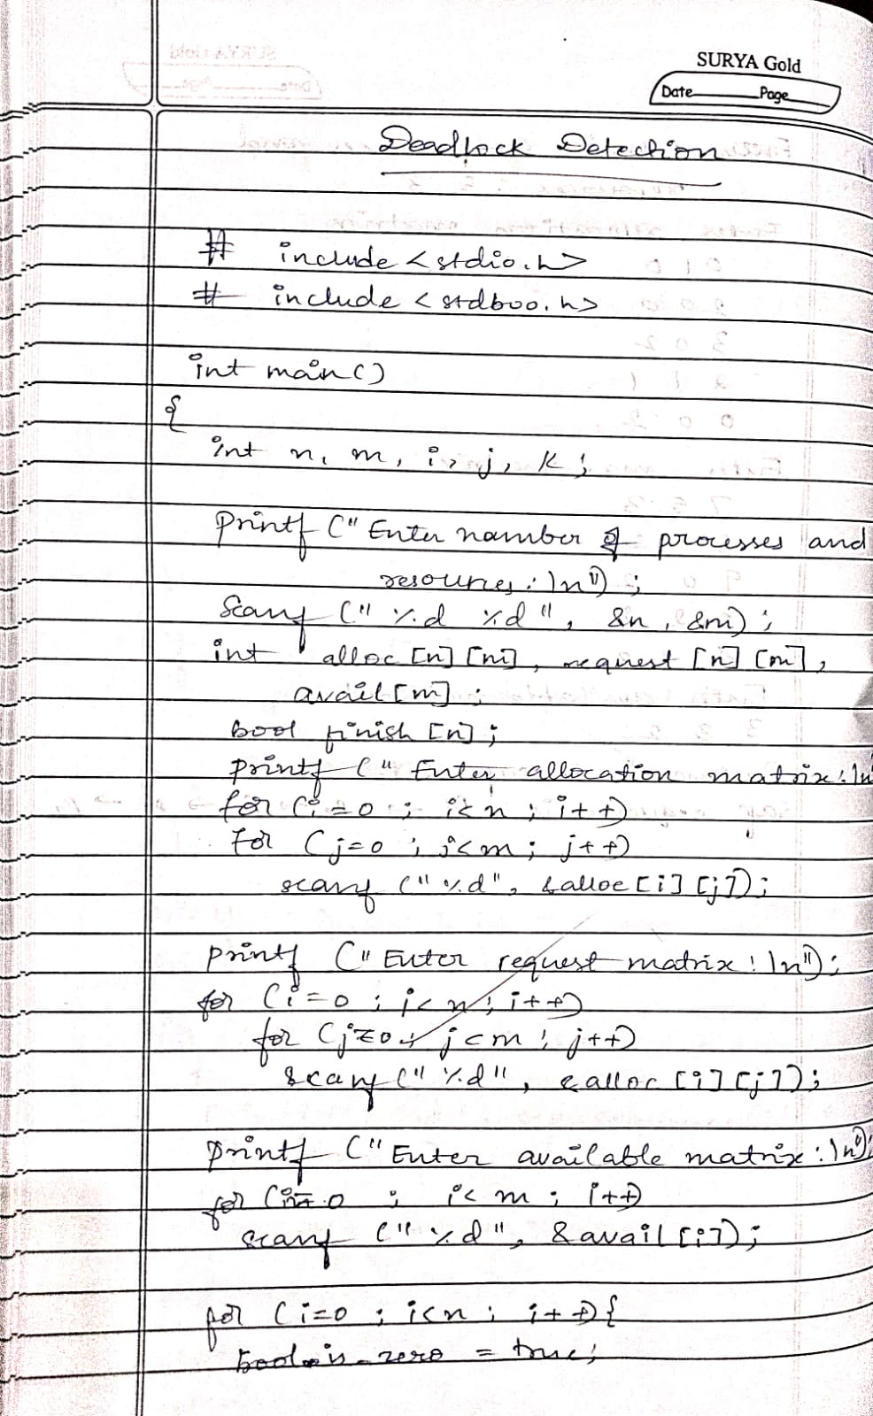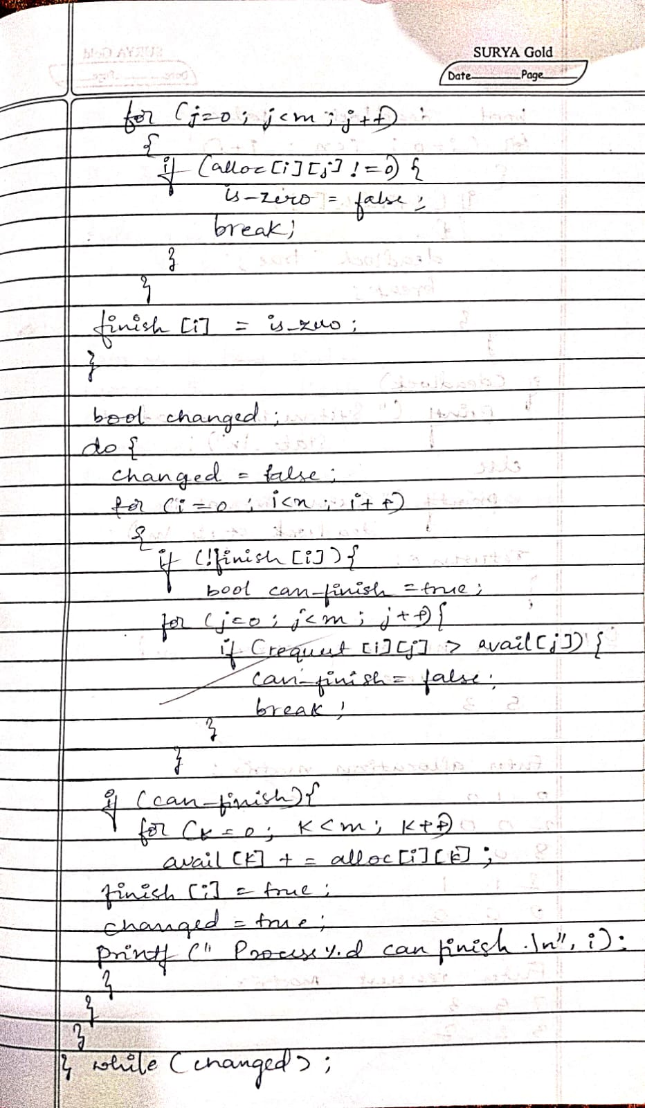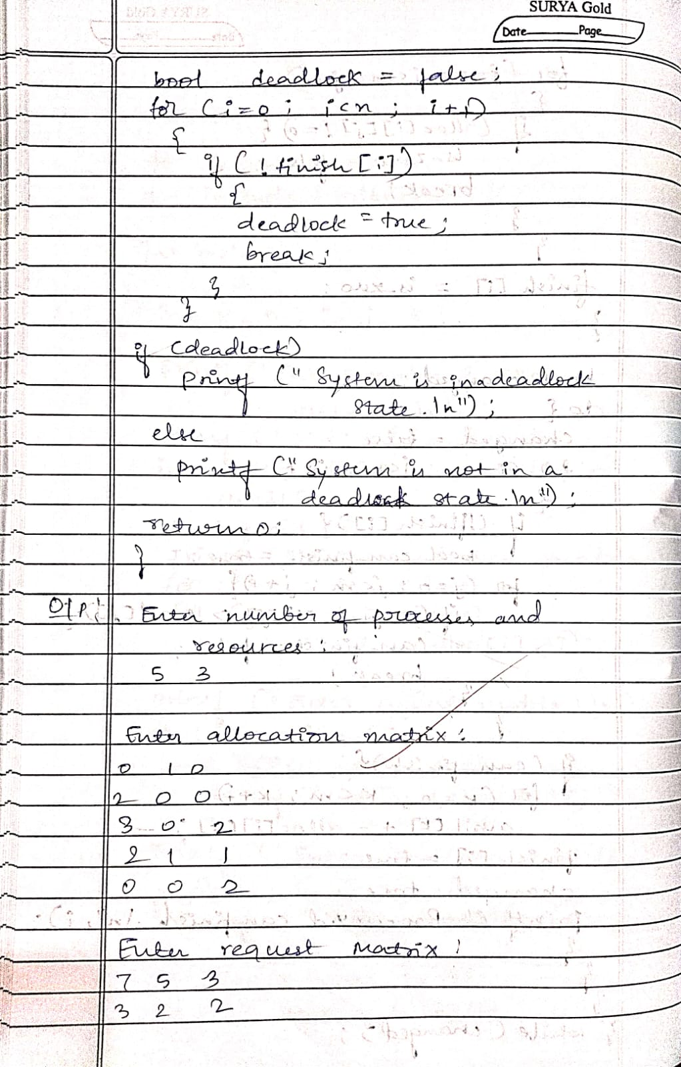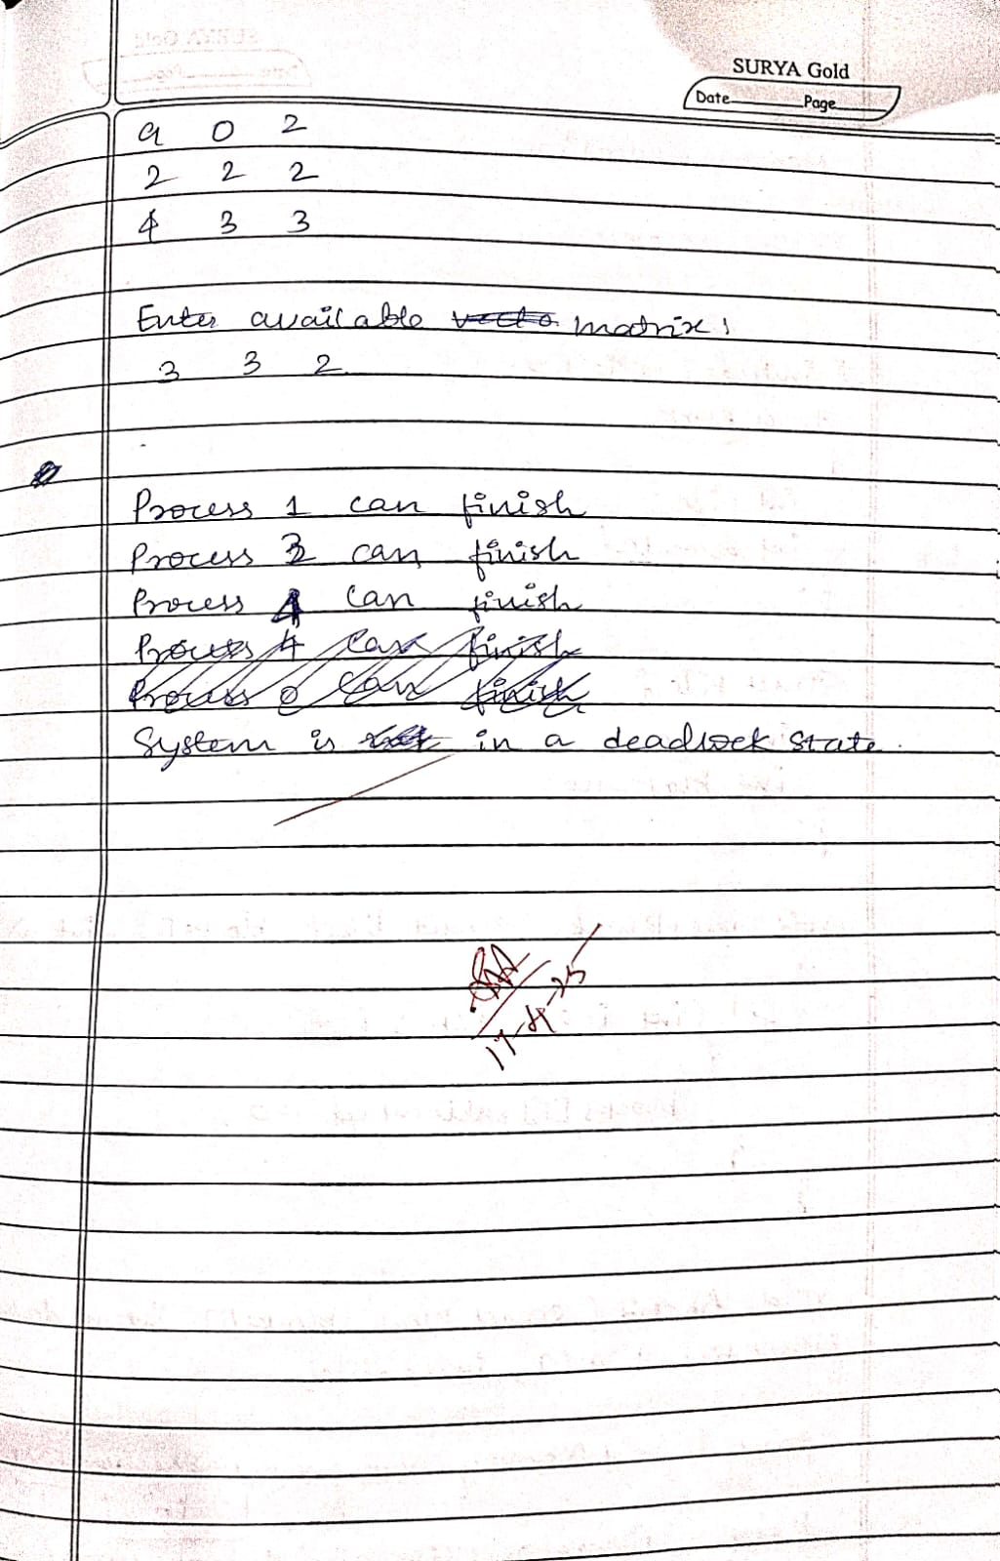Program -9

Question

Write a C program to simulate the following contiguous memory allocation techniques

1. Worst-fit
2. Best-fit
3. First-fit

Code

#include <stdio.h>

struct Block {

    int size;

    int allocated;

};

struct File {

    int size;

    int block_no;

};

void resetBlocks(struct Block blocks[], int n) {

    for (int i = 0; i < n; i++) {

        blocks[i].allocated = 0;

    }

}

void firstFit(struct Block blocks[], int n_blocks, struct File files[], int n_files) {

    printf("\n\tMemory Management Scheme � First Fit\n");

    printf("File_no:\tFile_size\tBlock_no:\tBlock_size:\n");

    for (int i = 0; i < n_files; i++) {

        files[i].block_no = -1;

        for (int j = 0; j < n_blocks; j++) {

            if (!blocks[j].allocated && blocks[j].size >= files[i].size) {

                files[i].block_no = j + 1;

                blocks[j].allocated = 1;

                printf("%d\t\t%d\t\t%d\t\t%d\n", i + 1, files[i].size, j + 1, blocks[j].size);

                break;

            }

        }

        if (files[i].block_no == -1) {

            printf("%d\t\t%d\t\t_\t\t_\n", i + 1, files[i].size);

        }

    }

}

void bestFit(struct Block blocks[], int n_blocks, struct File files[], int n_files) {

    printf("\n\tMemory Management Scheme � Best Fit\n");

    printf("File_no:\tFile_size\tBlock_no:\tBlock_size:\n");

    for (int i = 0; i < n_files; i++) {

        int bestIdx = -1;

        for (int j = 0; j < n_blocks; j++) {

            if (!blocks[j].allocated && blocks[j].size >= files[i].size) {

                if (bestIdx == -1 || blocks[j].size < blocks[bestIdx].size) {

                    bestIdx = j;

                }

            }

        }

        if (bestIdx != -1) {

            blocks[bestIdx].allocated = 1;

            files[i].block_no = bestIdx + 1;

            printf("%d\t\t%d\t\t%d\t\t%d\n", i + 1, files[i].size, bestIdx + 1, blocks[bestIdx].size);

        } else {

            printf("%d\t\t%d\t\t_\t\t_\n", i + 1, files[i].size);

        }

    }

}

void worstFit(struct Block blocks[], int n_blocks, struct File files[], int n_files) {

    printf("\n\tMemory Management Scheme � Worst Fit\n");

    printf("File_no:\tFile_size\tBlock_no:\tBlock_size:\n");

    for (int i = 0; i < n_files; i++) {

        int worstIdx = -1;

        for (int j = 0; j < n_blocks; j++) {

            if (!blocks[j].allocated && blocks[j].size >= files[i].size) {

                if (worstIdx == -1 || blocks[j].size > blocks[worstIdx].size) {

                    worstIdx = j;

                }

            }

        }

        if (worstIdx != -1) {

            blocks[worstIdx].allocated = 1;

            files[i].block_no = worstIdx + 1;

            printf("%d\t\t%d\t\t%d\t\t%d\n", i + 1, files[i].size, worstIdx + 1, blocks[worstIdx].size);

        } else {

            printf("%d\t\t%d\t\t_\t\t_\n", i + 1, files[i].size);

        }

    }

}

int main() {

    int n_blocks, n_files, choice;

    printf("Memory Management Scheme\n");

    printf("Enter the number of blocks: ");

    scanf("%d", &n_blocks);

    printf("Enter the number of files: ");

    scanf("%d", &n_files);

    struct Block blocks[n_blocks];

    struct File files[n_files];

    printf("\nEnter the size of the blocks:\n");

    for (int i = 0; i < n_blocks; i++) {

        printf("Block %d: ", i + 1);

        scanf("%d", &blocks[i].size);

        blocks[i].allocated = 0;

    }

    printf("Enter the size of the files:\n");

    for (int i = 0; i < n_files; i++) {

        printf("File %d: ", i + 1);

        scanf("%d", &files[i].size);

    }

    do {

        printf("\n1. First Fit\n2. Best Fit\n3. Worst Fit\n4. Exit\n");

        printf("Enter your choice: ");

        scanf("%d", &choice);

        resetBlocks(blocks, n_blocks); // Reset block allocation before each strategy

        switch (choice) {

            case 1:

                firstFit(blocks, n_blocks, files, n_files);

                break;

            case 2:

                bestFit(blocks, n_blocks, files, n_files);

                break;

            case 3:

                worstFit(blocks, n_blocks, files, n_files);

                break;

            case 4:

                printf("\nExiting...\n");

                break;

            default:

                printf("Invalid choice.\n");

        }

    } while (choice != 4);

    return 0;

}

Output:

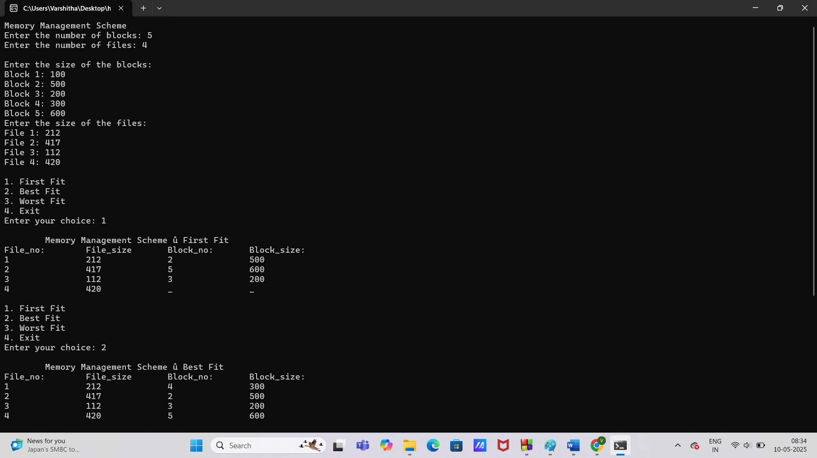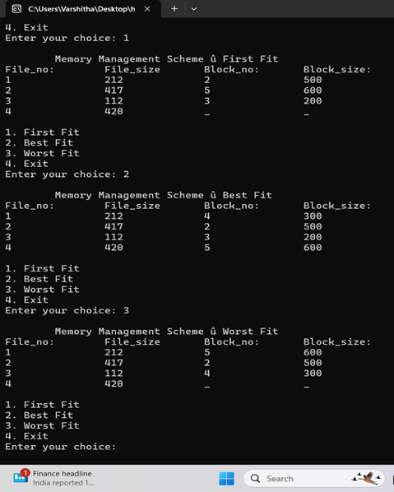

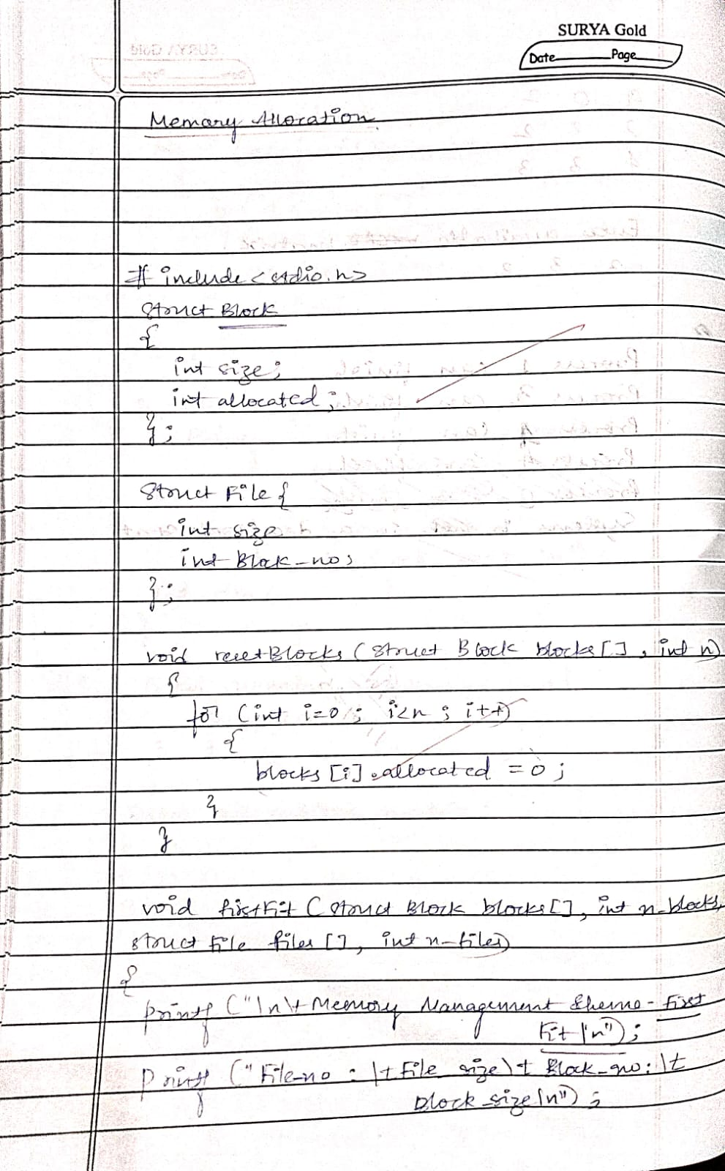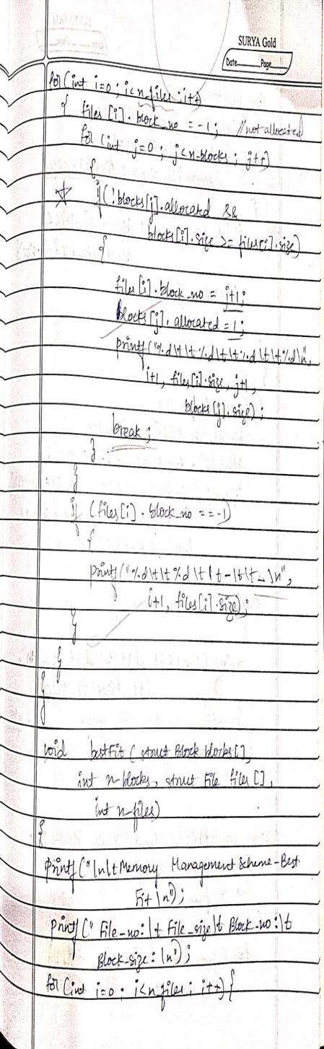

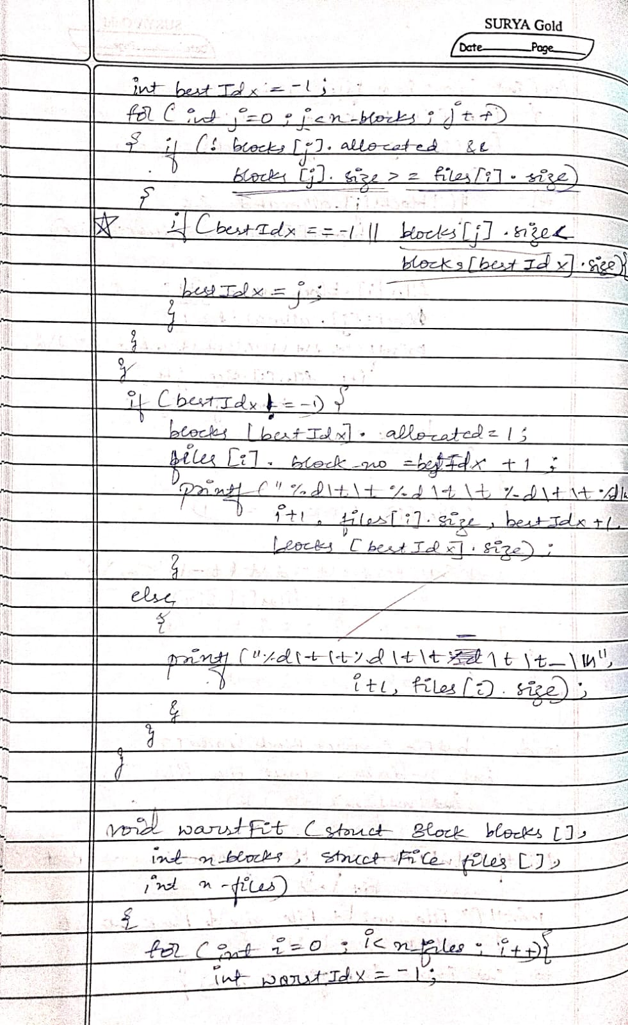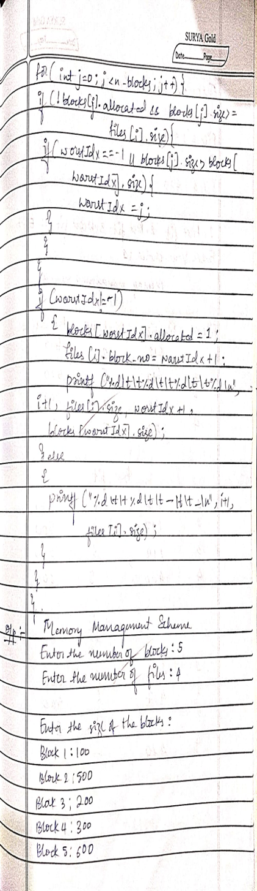

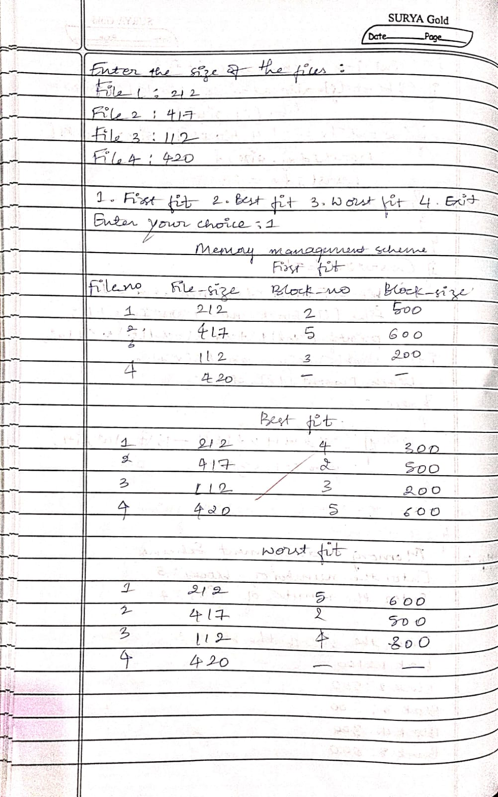

Program -10

Question

Write a C program to simulate page replacement algorithms

1. FIFO
2. LRU
3. Optimal

a)

Code

// FIFO

#include <stdio.h>

int main() {

    int frames, pages[50], n, frame[10], i, j, k, avail, count = 0;

    printf("Enter number of pages: ");

    scanf("%d", &n);

    printf("Enter the page reference string:\n");

    for(i = 0; i < n; i++)

        scanf("%d", &pages[i]);

    printf("Enter number of frames: ");

    scanf("%d", &frames);

    for(i = 0; i < frames; i++)

        frame[i] = -1;

    printf("\nPage\tFrames\t\tPage Fault\n");

    j = 0;

    for(i = 0; i < n; i++) {

        avail = 0;

        for(k = 0; k < frames; k++) {

            if(frame[k] == pages[i]) {

                avail = 1;

                break;

            }

        }

        if(avail == 0) {

            frame[j] = pages[i];

            j = (j + 1) % frames;

            count++;

            printf("%d\t", pages[i]);

            for(k = 0; k < frames; k++) {

                if(frame[k] != -1)

                    printf("%d ", frame[k]);

                else

                    printf("- ");

            }

            printf("\tYes\n");

        } else {

            printf("%d\t", pages[i]);

            for(k = 0; k < frames; k++) {

                if(frame[k] != -1)

                    printf("%d ", frame[k]);

                else

                    printf("- ");

            }

            printf("\tNo\n");

        }

    }

    printf("\nTotal Page Faults = %d\n", count);

    return 0;

}Output:

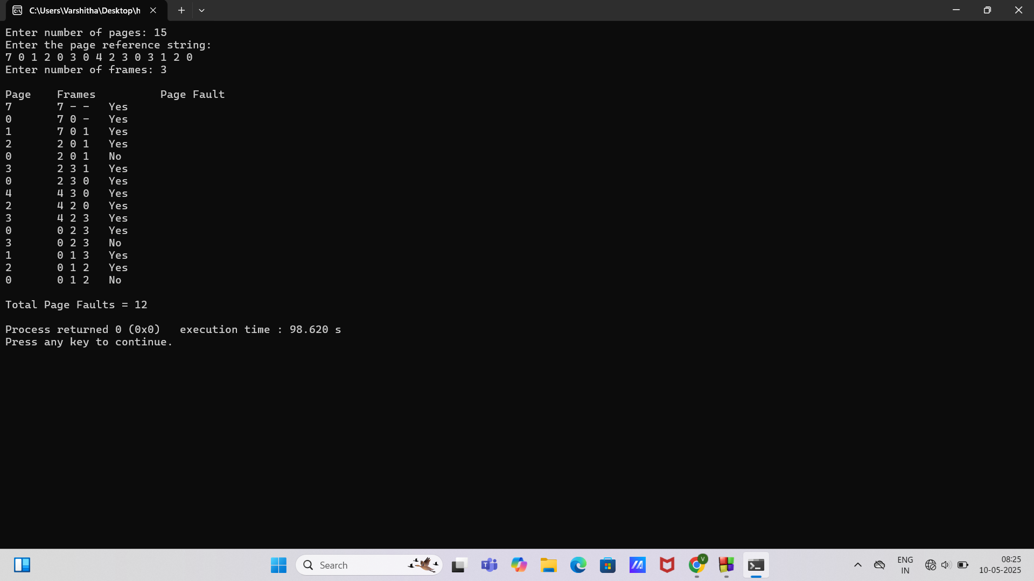

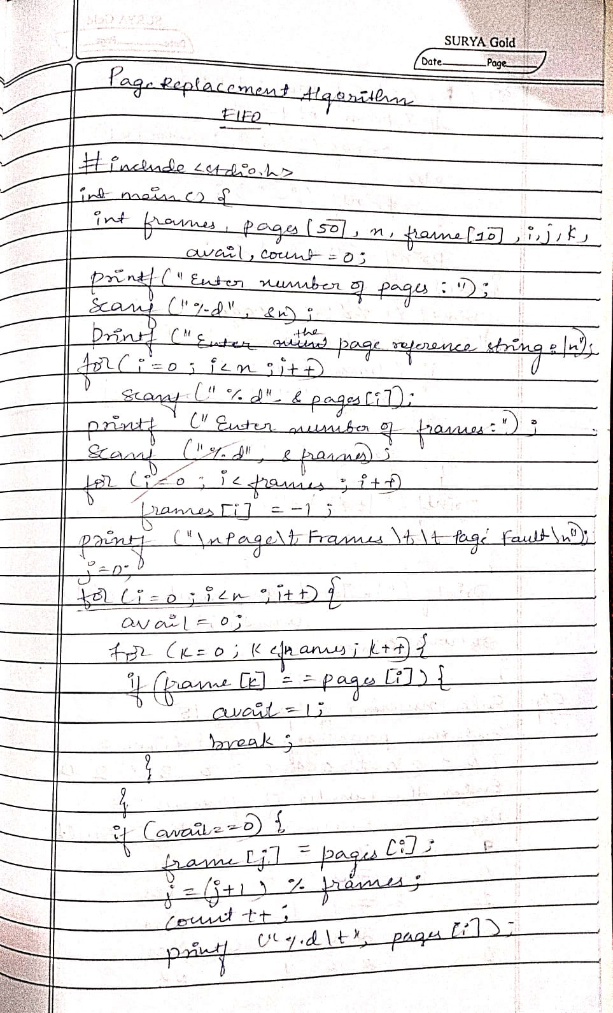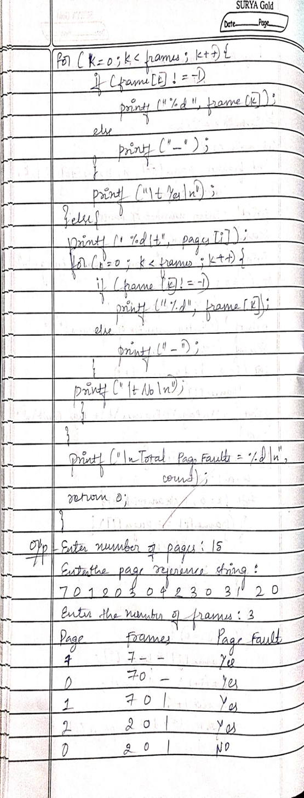

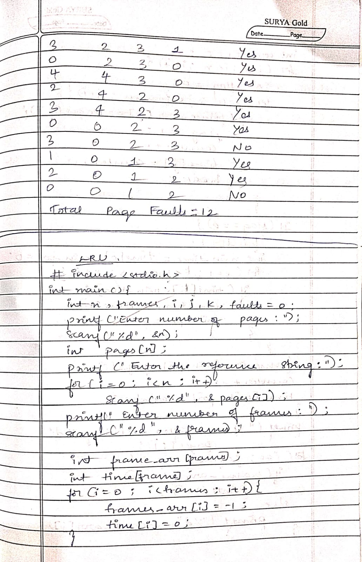

b)

Code

//LRU

#include <stdio.h>

int main() {

    int n, frames, i, j, k, faults = 0;

    printf("Enter number of pages: ");

    scanf("%d", &n);

    int pages[n];

    printf("Enter the reference string: ");

    for(i = 0; i < n; i++)

        scanf("%d", &pages[i]);

    printf("Enter number of frames: ");

    scanf("%d", &frames);

    int frame_arr[frames];

    int time[frames]; // To track the usage time

    for(i = 0; i < frames; i++) {

        frame_arr[i] = -1;

        time[i] = 0;

    }

    int counter = 0;

    for(i = 0; i < n; i++) {

        int flag = 0;

        for(j = 0; j < frames; j++) {

            if(frame_arr[j] == pages[i]) {

                flag = 1;

                counter++;

                time[j] = counter; // Update the usage time

break;

            }

        }

        if(flag == 0) { // Page fault

            faults++;

            int min_time = time[0], min_pos = 0;

            for(k = 1; k < frames; k++) {

                if(time[k] < min_time) {

                    min_time = time[k];

                    min_pos = k;

                }

            }

            frame_arr[min_pos] = pages[i]; // Replace the least recently used

            counter++;

            time[min_pos] = counter; // Update the usage time for the new page

        }

        printf("Frames after accessing %d: ", pages[i]);

        for(j = 0; j < frames; j++) {

            if(frame_arr[j] == -1)

                printf("- ");

            else

                printf("%d ", frame_arr[j]);

        }

        printf("\n");

    }

    printf("Total page faults: %d\n", faults);

    int Hits = n-faults;

    printf("Total page Hits: %d\n",Hits);

    return 0;

}

Output:

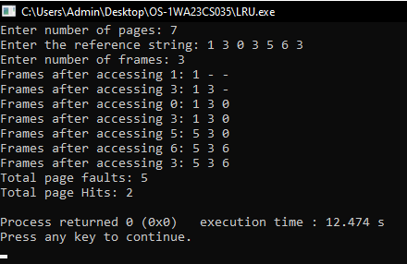

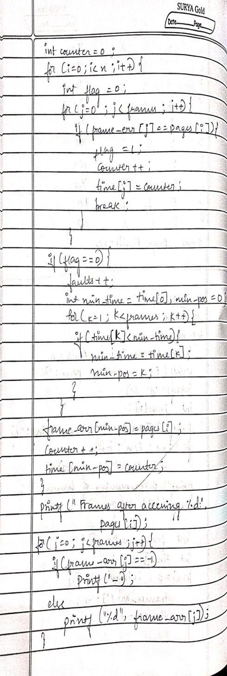

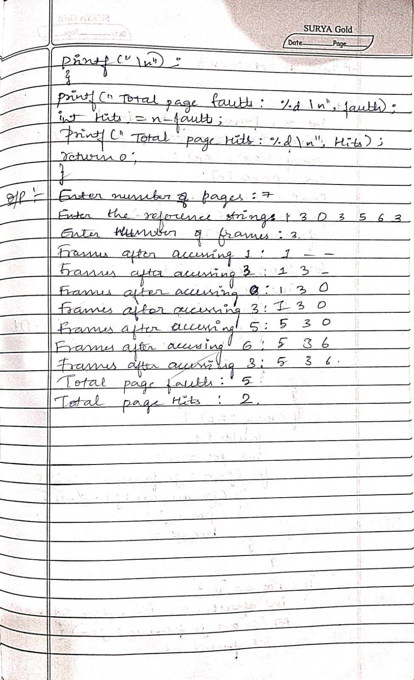

c)

Code

//OPTIMAL

#include <stdio.h>

int main() {

    int n, frames, i, j, k, faults = 0;

    printf("Enter number of pages: ");

    scanf("%d", &n);

    int pages[n];

    printf("Enter the reference string: ");

    for(i = 0; i < n; i++)

        scanf("%d", &pages[i]);

    printf("Enter number of frames: ");

    scanf("%d", &frames);

    int frame_arr[frames];

    for(i = 0; i < frames; i++)

        frame_arr[i] = -1;

    for(i = 0; i < n; i++) {

        int flag = 0;

        for(j = 0; j < frames; j++) {

            if(frame_arr[j] == pages[i]) {

                flag = 1;

                break;

            }

        }

        if(flag == 0) { // Page fault

            faults++;

            int pos = -1;

            for(j = 0; j < frames; j++) {

                if(frame_arr[j] == -1) {

                    pos = j;

                    break;

                }

            }

            if(pos == -1) { // Need to replace a page

                int farthest = i, replace_index = 0;

                for(j = 0; j < frames; j++) {

                    int found = 0;

                    for(k = i + 1; k < n; k++) {

                        if(frame_arr[j] == pages[k]) {

                            if(k > farthest) {

                                farthest = k;

                                replace_index = j;

                            }

                            found = 1;

                            break;

                        }

                    }

                    if(!found) {

                        replace_index = j;

                        break;

                    }

                }

                pos = replace_index;

            }

            frame_arr[pos] = pages[i];

        }

        printf("Frames after accessing %d: ", pages[i]);

        for(j = 0; j < frames; j++) {

            if(frame_arr[j] == -1)

                printf("_ ");

            else

                printf("%d ", frame_arr[j]);

        }

        printf("\n");

    }

    printf("Total page faults: %d\n", faults);

    int Hits = n-faults;

    printf("Total page Hits: %d\n",Hits);

    return 0;

}

Output:

